FEDERAL STATE AUTONOMOUS EDUCATIONAL INSTITUTION

OF HIGHER EDUCATION
«NATIONAL RESEARCH UNIVERSITY
«HIGHER SCHOOL OF ECONOMICS»
Graduate Business School

DIGITAL TECHNOLOGIES AND CROWDFUNDING FOR ENTREPRENEURSHIP IN EMERGING MARKETS

Final qualifying work – MASTER THESIS
Educational program “International management”

Professor: Tekic Anja
2th year Student
Tashchyan Ani

MOSCOW, 2024
Table of contents
Abstract 3
1. Introduction 3
Actuality 4
2. Theoretical background 6
2.1. Crowdfunding in emerging economies 6
2.1.1. Crowdfunding theory 6
2.1.2. Advanced Technologies and Crowdfunding 12
2.2. Institutional theory 14
2.2.1. Regulatory dimension 14
2.2.1.1. Key Regulatory Requirements for Crowdfunding 14
2.2.1.3. Advanced economies 15
2.2.1.3. Emerging economies 16
2.2.2. Normative dimension 18
2.2.3. Cognitive dimension 20
2.3. Influence of regulatory, normative and cognitive institutions on adoption of crowdfunding in emerging economies 22
3. Methodology 24
3.1. Qualitative Comparative Analysis (QCA) 24
3.2.Data collection 25
Survey method and structure 25
3.3 Data analysis 27
4. Results 28
4.1. Survey results 28
4.2. Observations from descriptive statistics 29
4.3. QCA results 33
5. Discussion 38
5.1. Institutions impact on adoption of crowdfunding in emerging economies 38
5.2. New ecosystem and perspective for digital crowdfunding 39
6. Conclusions 41
6.1. Contribution to research 41
6.2. Practical implications 43
Crowdfunding platforms 43
Entrepreneurs(Campaigners) 43
Policy Makers 44
Researchers 44
6.3. Limitations and future research 44
6.4. Final remarks 45
References 46

Abstract
In the digital age of the 21st century, digital crowdfunding in emerging markets is still at an early stage of development. In developed countries, the transformation stage is now underway, fintech solutions are being introduced and crowdfunding support is being used to finance new enterprises, and sustainable personalization measures are being implemented. In emerging economies, the situation is exactly the opposite: access to financial services is considered one of the main constraints, and crowdfunding is in the early stages of implementation. The study is new, and it is unclear why there is a lack of entrepreneurial activity in crowdfunding in developing countries. Within the framework of this study, the causes of entrepreneurial activity in crowdfunding are considered from an institutional point of view. Focusing on the implementation of crowdfunding in emerging market countries from an institutional point of view, the study analyzes how cognitive, regulatory and regulatory institutions influence the intentions and behavior of entrepreneurs in the decision-making process on financing their startups. The results obtained go beyond the scope of the study and are of practical and theoretical value for solving this problem.

1. Introduction
Entrepreneurship is a combination of creativity and innovation needed to start a new business. (Philip, Dennett, 2022) This is seen as a multilevel phenomenon requiring a focus on “the intersection of individual structures, capabilities, ways of organizing and the environment" (Busenitz et al., 2003, p. 285). In particular, entrepreneurs demonstrate unique characteristics (e.g. mood, perception, cognitive abilities, emotional stability, conscientiousness, self-confidence and centrality in work) that push people to develop entrepreneurial abilities (Van Ness & Seifert, 2016). Three institutional pillars, derived by Scott (1995) and adapted by Kostova (1997) and Busenitz et al. (2000), provide a theoretical framework for our measurement of entrepreneurship. Scott's Three Pillars (1995)–regulatory, cognitive, and regulatory institutions-provide stability and incentives that promote or hinder social behavior in the economy. (Stenholm et al., 2010) These characteristics encourage entrepreneurs to adopt digital technologies and benefit from crowdfunding due to their ability to design crowdfunding campaigns better than others and attract more funding. (Chalmers et al., 2021, 1028-1053) Thus, crowdfunding is considered an intermediary system in which entrepreneurial ventures raise funding, instead of the traditional lending system without the need for financial intermediaries (cf. Mollick, 2014). Incorporating advanced technology terms in project pitches positively impacts crowdfunding success. The adoption of digital payments, 5G infrastructure, smartphone penetration, and the vision of Society 5.0 has revolutionized the entrepreneurial landscape in these markets, presenting valuable opportunities for entrepreneurs to leverage these technologies for value creation. As a result, there has been an increasing embrace of various digital technologies, such as artificial intelligence (AI), machine learning, biometrics, and robotics, to optimize operations and scale up business models. Although previous studies have argued that digital technologies may be viableavenues for entrepreneurial ventures in emerging markets to access new sources of funding(Hemmert, et al., 2022), knowledge seems to be patchy on how these digital technologies are helping build resilience and scaling up of business models through crowdfunding in entrepreneurial ventures in emerging markets. In particular, the experiences of entrepreneurial ventures through digitally enabled-crowdfunding channels in emerging markets seem to be left out of the existing scholarly discourse. (Cavallo, A., 2024) The study focuses on the challenges faced by entrepreneurs when using digital crowdfunding in emerging markets, by conducting a comprehensive analysis based on institutional theory to determine how these problems differ from those in developed markets, and identify models and structures that will help minimize institutional impact through digital technologies and provide new strategies for start-up financing.

Actuality
Problem actuality
Personalization of crowdfunding in Industry 5.0 provides a theoretical basis and practical reference for crowdfunding platforms and financiers to realize Innovation 5.0 in order to promote the sustainable development of crowdfunding. (Wang et al, 2024) Sustainability crowdfunding campaigns have been organized, and are notably common in more innovative and less bureaucratic regions, exemplified by Switzerland. (Business Model Innovation and Industry 5.0: A Possible Integration in GLAM Institutions, 2009).
The emerging FinTech solutions like cryptocurrencies are challenging the role of intermediaries, such as governments or brokers of traditional currency. In this context, the overlapping of cryptocurrencies with crowdfunding – financial systems without intermediaries – decouples economic activities from physical facilities. The zero trust networks and humanoid robots further add to the location independent secure access. Financial institutions such as banks, crowd funding wealth management companies and insurance enterprises are adapting their customer services to FinTech offerings. (Imran Taj & NZ Jhanji, 2022) In developing countries or emerging markets, the scenario is completely different: offline crowdfunding activities remain significant due to the lack of access to digital technologies.(Cavallo, A., 2024) Access to finance is considered to be the biggest constraint to doing business for entrepreneurial ventures in emerging markets (World Bank, 2020). For young innovators the lack of internal cash flows and collaterals, as well as asymmetric information and agency problems are the main reasons for the difficulties in raising external funding. The most of the difficulties arose after the 2008/2009 financial crisis, combined with increased technological opportunities, changed requirements in firms’ product markets, globalization, and regulatory changes. These difficulties firms encounter in raising seed and start-up capital play an increasingly important role in the policy agenda of local, national and international governmental institutions, as is documented in the measures included in the Horizon 2020 and COSME projects funded by the European Commission. Given that venture capital penetrates in its infancy in most emerging markets, entrepreneurs are exposed to high-interest credit facilities at traditional banks and micro-finance institutions. It is, therefore, critical to examine how digital technologies are helping entrepreneurial ventures from emerging markets to access global funding platforms, as the prevalence of crowdfunding avenues for entrepreneurial ventures is advancing faster than the associated academic literature. (Cavallo, A., 2024)

Purpose of Study.
The research aims to bridge the gap in the scientific literature regarding the impact of digital technologies on entrepreneurial finance in emerging markets, providing practical insights and advancing theoretical understanding in the field (Cavallo, 2024), by measuring multidimensional indicators of the environment supporting entrepreneurial activity in order to obtain a more detailed and stable relationship between institutional mechanisms at the country level.
The research includes following steps:
- Literature review based on Crowdfunding Theory and the Institutional theory, understanding the patterns and relationship between factors shaping entrepreneurial activity, formulating hypotheses relying on Planned Behaviour and Institutional Pillars theories.
- Data collected by informal interviews and gathering survey responses from entrepreneurs worldwide, Fuzzy-set Qualitative Comparative Analysis (fsQCA) employment on the sample of 48 emerging startups and getting actual data, covering the issue of aging academic literature by providing nowadays data. Hypotheses testing.
- Discussion of the results, practical implications and limitations for further research.

The object of the study is the influence of institutional mechanisms on the entrepreneur's intentions to use digital technologies and crowdfunding to create new entrepreneurial enterprises around the world.
The subject of the study is the pattern identification that shapes the problems faced by entrepreneurial enterprises in emerging markets, with an emphasis on the use of digital technologies and the dynamics of crowdfunding activities in these regions.

2. Theoretical background

2.1. Crowdfunding in emerging economies
Financial intermediaries provide services in imperfect markets characterized by transaction costs (Benston and Smith, 1976; Gurley and Shaw, 1966) and information asymmetry (Campbell and Krakoue, 1980; Fama, 1980; Leland and Pyle, 1977; Schumpeter, 1939).
In the context of information asymmetry, emerging economies are often seen as a separate group from industrialized countries, as they tend to be more risky, but expected returns are also higher than in industrialized countries. (W.A. de Wet, 2004) Financial institutions face difficulties in servicing small and medium-sized enterprises in developing countries, often unable to develop cost-effective approaches to conducting relatively small transactions, which involves relatively high risks. (Cortina and Schmuckler, 2018) The tendency of entrepreneurs to operate in the informal sector is a result of the asymmetry between those formal institutions and informal institutions: the greater the incongruence between formal and informal institutions, the more entrepreneurs operate in the informal sector. (Williams & Shahidb, 2014). Crowdfunding allows to reduce the transaction costs and information asymmetry and raise funds for a wide range of niche projects that would have limited access to more traditional sources of financing. In a sense, crowdfunding platforms can be considered as information intermediaries between investors of different types and enterprises, the ultimate goal of which is to reduce information asymmetry and ensure successful financing.

2.1.1. Crowdfunding theory
Crowdfunding for entrepreneurship is the practice of obtaining small amounts of capital from a large pool of individual investors to finance new entrepreneurial endeavors or projects (Brem et al., 2019; Samarah & Alkhatib, 2019). Although crowdfunding has been around for a long time, the advent of the Internet is making it easier to use and more visible and accessible to millions of people, making it the preferred method of financing (Beugre, 2014) despite the fact, that in emerging markets or developing countries with limited access to digital technologies, offline crowdfunding activities are still important. (Cavallo, A., 2024)
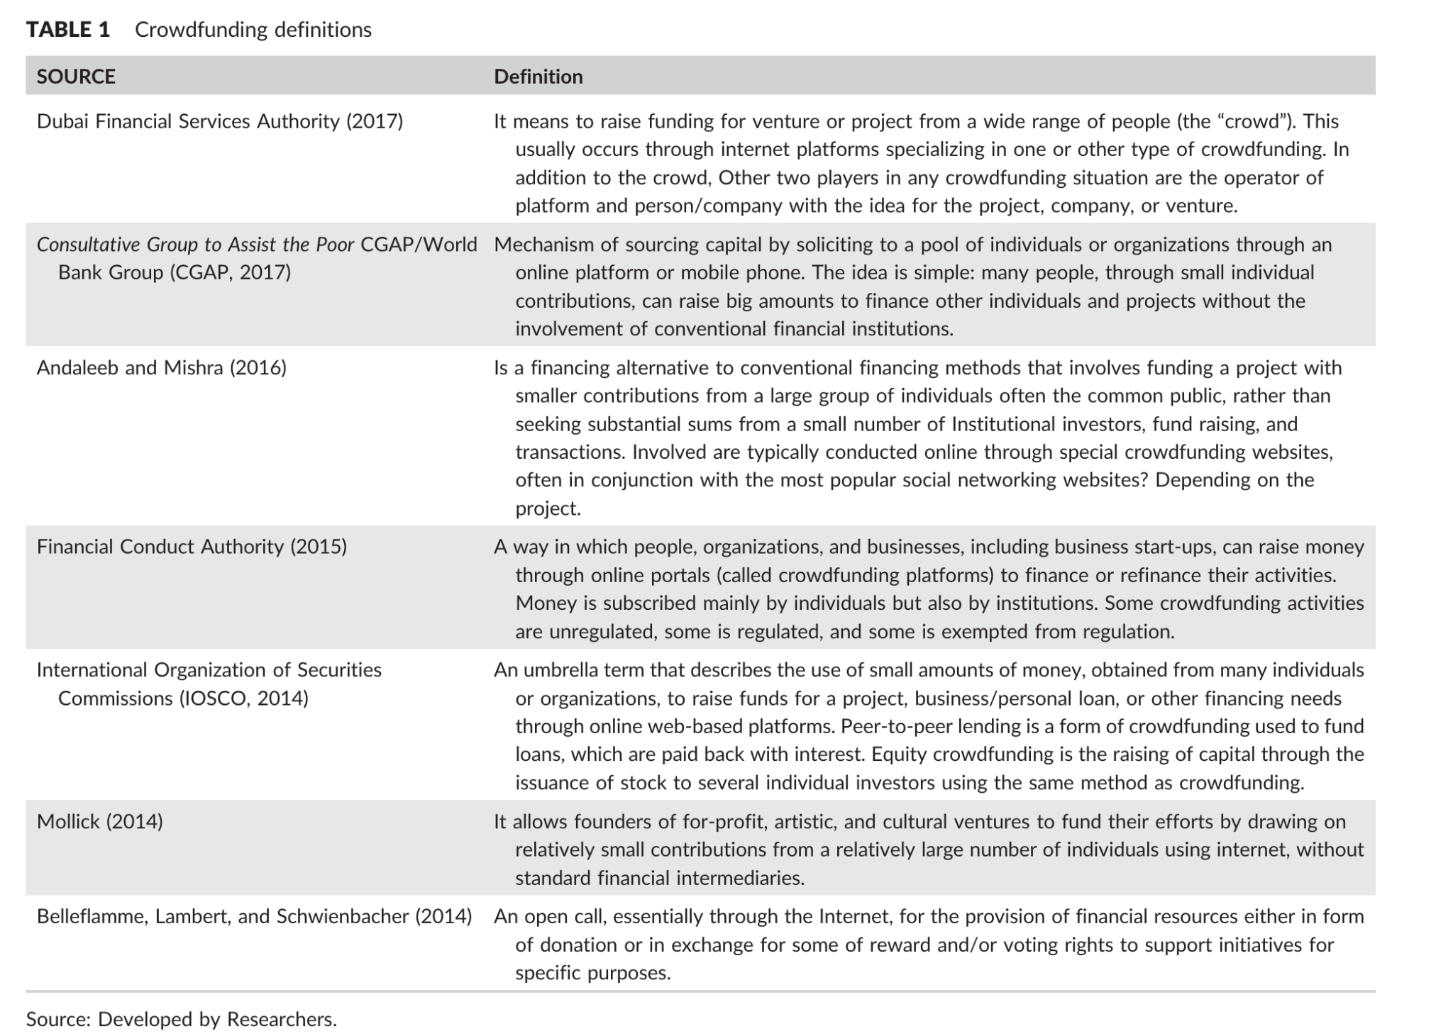
Table 1: Crowdfunding definitions over time
Source: (Samarah & Alkhatib, 2019)

The concept of crowdfunding is rooted in a wider concept of crowdsourcing, which refers to using the crowd to gain ideas, feedback, and solutions to develop new products or business solutions. (Belleflamme et al., 2014; Ibrahim, 2012; Kleemann et al., 2019; Kuppuswamy & Bayus, 2013; Mitra, 2012; Samarah & Alkhatib, 2019) Crowdsourcing is the act of a company or institution taking a job traditionally performed by a designated agent and outsourcing it to an undefined, generally large group of people in the form of an open call (Howe, 2009; Beugre, 2014). As crowdsourcing allows companies to outsource some of their activities to a large number of outside people, customers and other businesses, crowdfunding allows entrepreneurs to secure the needed capital by relying on several small investors. (Beugre, 2014).

Financial intermediation theory, including crowdfunding, builds on models of resource allocation between capital-seeking and capital-giving agents by a market-making mechanism (Benston and Smith 1976). Crowdfunding platforms serve as brokers between the capital seeking agents and the capital-giving agents(the crowd), but also increasingly to institutional investors and markets (Lehner, Grabmann, and Enns Graber 2015; Mollick 2014).

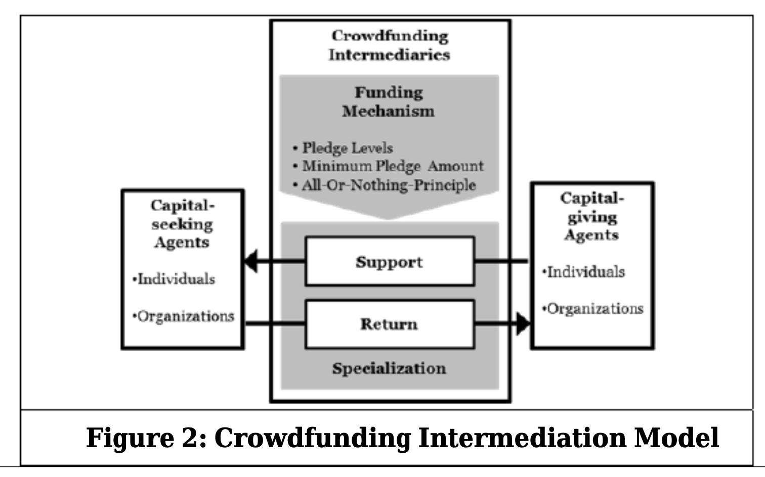

Figure 1: Crowdfunding Intermediation Model
Source: (Blohm et al., 2014)

The three main participants in crowdfunding transactions are the fundraiser (capital raising agent), the sponsor (capital provision agent) and the platform.
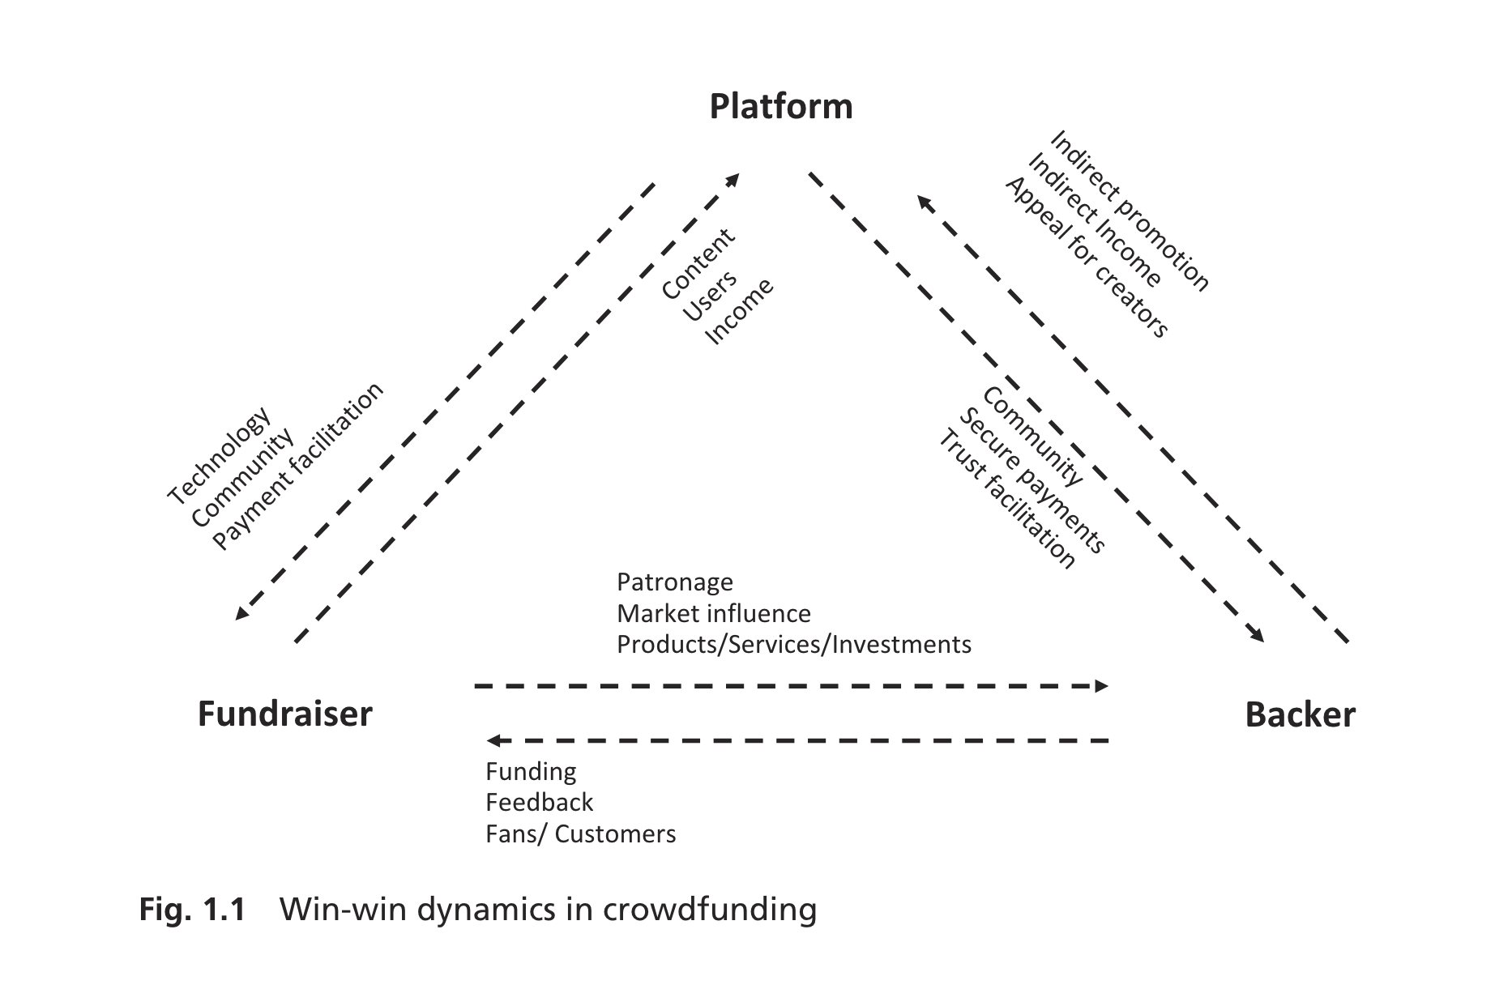
Figure 2: Win-win dynamics in crowdfunding
Source: (Shneor, 2020)

Bradford (2012) distinguishes five types of donations between intermediaries in crowdfunding from a legal point of view because the agents providing capital receive in exchange for their investments: rewards, pre-orders, loans and equity participation (Bradford, 2012). Hemer (2011) distinguishes the seven types of donation, sponsoring, pre-ordering, membership fees, crediting, lending, and profit-sharing. These classifications have conceptual nature and are neither theoretically grounded nor empirically validated, and neglect the role of crowdfunding as financial intermediation and two-sided market, which are the pivotal ideas underlying the concept. (Blohm et al., 2014) A more recent addition to the crowdfunding models has been invoice trading, which is considered as a “fast and easy way in which small and medium sized enterprises (SMEs) can raise short-term debt by refinancing their outstanding invoices through individual or institutional investors” (Dorfleitner et al. 2017, p. 56; Shneor, 2020).
Equity crowdfunding refers to backers buying an ownership stake in an organization. Reward crowdfunding refers to backers providing funding in exchange for non-monetary rewards, most frequently in the form of pre-purchased products or services. Crowd-lending refers to individual or institutional backers providing loans to borrowers while expecting the repayment of the principle and a set interest within a predefined time frame. Donation crowdfunding is a provision of funding based on philanthropic or civic motivations without expectation of material rewards. There is no compensation if the agents providing the funds support projects aimed at the common good (donations). (Shneor & Vik, 2020) Remuneration is paid if the agents providing the funds receive non-monetary income. The product is ordered in advance if the support of the agent providing the funds has been paid in advance. Interest is accrued if the agents providing the funds participated in the provision of the loan. Profit share, if the agents providing capital receive some share of participation in the project(campaign). (Blohm et al., 2014).
These crowdfunding models can be divided into what Belleflamme and Lambert (2016) called “investment models” or “non-investment models'', depending on the types of compensation promised and expected by sponsors. In particular, investment models involve equity lending and crowdfunding, offering financial returns to investors, while non-investment models include crowdfunding rewards and donations, offering non-financial returns to consumers and donors, respectively (Munim et al., 2020)
Haas et al. (2014) created an empirical taxonomy of intermediaries in crowdfunding, describing three different archetypes that fall into the categories of hedonism(addressing the investors’ sense of interest, desire or joy), altruism (attracting investors with an interest in the greater good) and profit-making(satisfying monetary needs).(Haas et al., 2014)
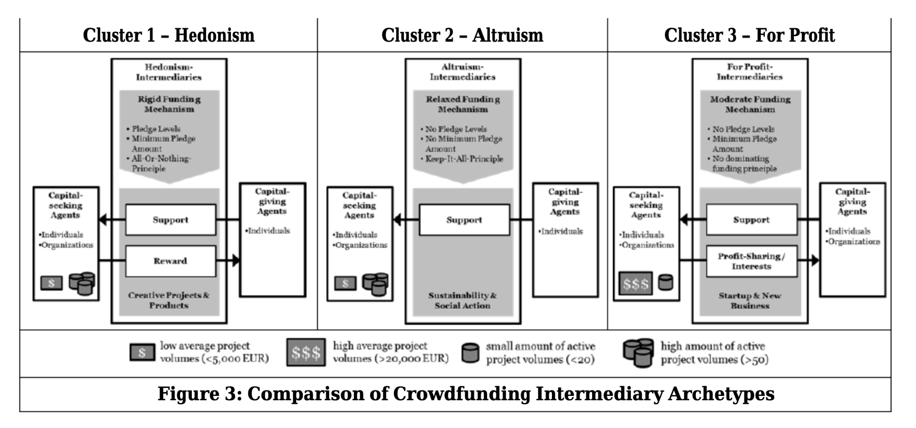
Figure 3: Comparison of Crowdfunding Intermediary Archetypes
Source: (Blohm et al., 2014)

Hedonistic intermediaries set themselves apart by providing incentives and focusing on creative endeavors. Donations to charities and sustainable social projects are made possible by altruistic intermediaries. (Haas et al., 2014)
The model of hedonism is very strict and emphasizes the importance of project feasibility to reduce risks for investors, while altruistic intermediaries show a moderate level of strictness to maximize the success of fundraising projects.(Haas et al., 2014)
Commercial intermediaries, mainly focused on new and start-up companies, offer profit shares and interest as income. Shneor(2020) created a detailed view of microventures through an extended organizational fundraiser model choice framework. (Shneor, 2020)
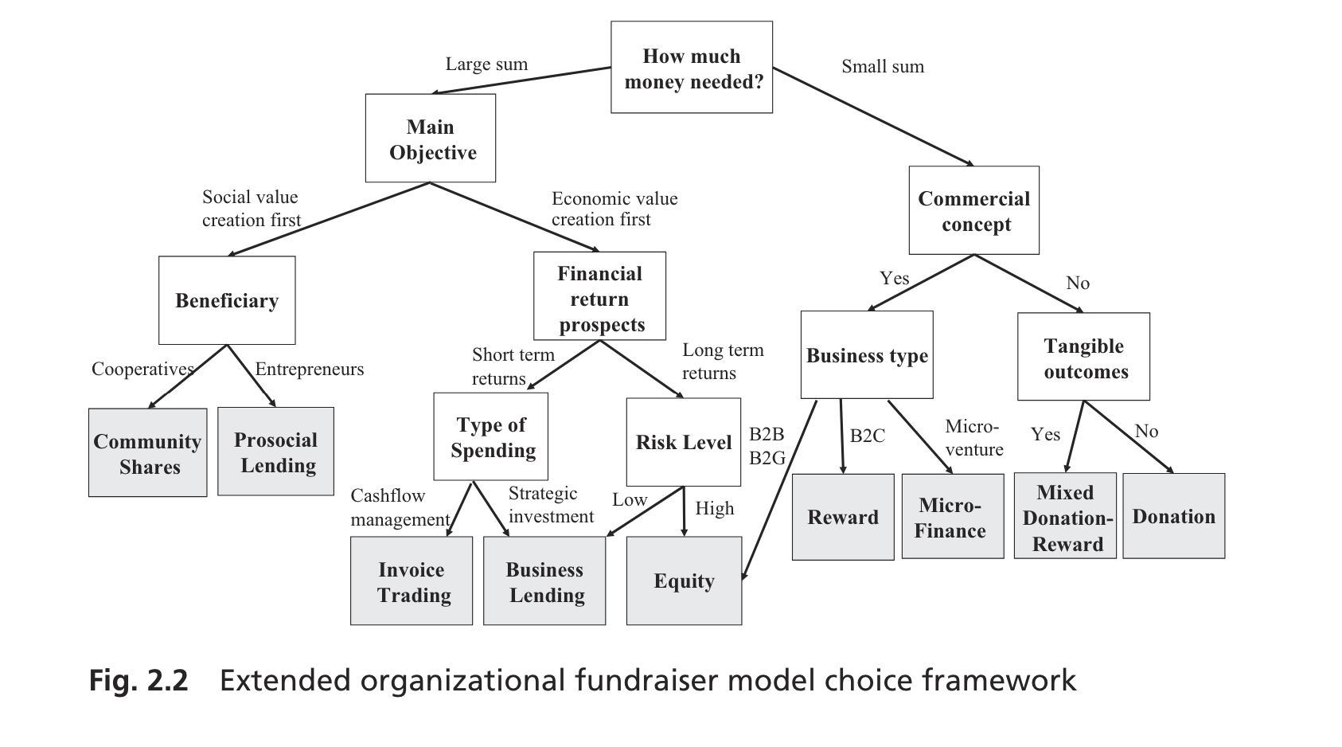
Figure 4: Extended organizational fundraiser model choice framework
Source: (Shneor, 2020)

Commercial intermediaries have moderate financing mechanisms. Minimum collateral requirements guarantee a regulated capital structure, on the one hand. Conversely, the ideas of "keep it all or nothing" apply. In the pursuit of profit, the main focus is on increasing sales (more than 20,000 euros) and reducing sales (less than 20,000 euros). (Haas et al., 2014; Blohm et al., 2014).
In 2019, Lehner and Harrer developed a crowdfunding ecosystem mechanism that links the crowdfunding process to all three parties involved and highlights the institutions’ impact on both enterprises and the operation of platforms. (Lehner and Harrer, 2019)
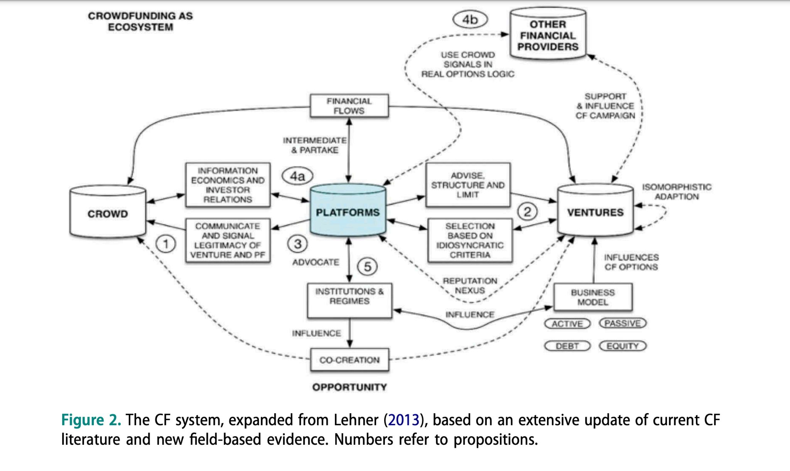
Figure 5: The CF system, expanded from Lehner(2013), based on an extensive update of current CF literature and new field-based evidence.
Source: (Lehner & Harrer, 2019)

2.1.2. Advanced Technologies and Crowdfunding
The development of digital technologies is changing the landscape of business financing, offering new financial opportunities and transforming traditional approaches to raising capital for entrepreneurial enterprises. Broadly defined, alternative finance refers to non-bank financial channels, which have proliferated in the last decade as part of technological advances in finance often referred to as Financial technology firms or – ‘FinTech’ (Haddad and Hornuf, 2019). The concept of FinTech represents the use of advanced technology to provide financial services(Samarah & Alkhatib, 2019). Utilizing FinTech can efficiently and effectively deliver financial services to end-users through various methods like stock trading, peer-to-peer lending, cryptocurrencies, payment transfers, and crowdfunding. (Milian et al., 2019; Alhammad et al., 2021). The contribution of distributed ledger technology (DLT) (e.g. blockchain) and smart contracts to the digitalisation and digital transformation of the construction sector is nascent but rapidly gaining traction. (Jennifer Li & Mohamad Kassem Show more, 2021) Here, improvements in technology are employed to address imbalances between demand and supply for alternative finance (Bruton et al., 2015). In recent years, in advanced economies technological advancements have been significant. FinTech start-ups are currently raising large sums of money, which might have a tremendous influence on entrepreneurial finance.
While traditional institutions were originally eliminated by crowdfunding, cryptocurrency crowdfunding typically eliminates any middlemen that may exist between the startup and its backers. These technologies offer new methods for evaluating risk and threat financial data that make it simpler for non-professional investors to participate in entrepreneurial financing, increase liquidity and lower investor monitoring costs. However because of increased connectivity brought about by securitization these technologies may also increase the risk of contagion. With the blockchain-based crowdfunding solution the general public can invest in projects using smart contracts and tokens with potential returns provided in the form of interest. KYC verification makes it possible to track investments and the public can benefit from the content market. While the solution eliminates the need for third-party payment processors and verification and offers benefits like transparency and confidentiality there is currently a lack of legal clarity surrounding smart contracts because they are still in their infancy. Smart contracts can currently be used even in the absence of blockchain technology. Therefore contract management systems could manage the contracts life cycle while eliminating the inherent limitations of the technology resolving the immutability issue and blockchains irreversible nature. (Hayashi et al. 2017). The latest studies on novel forms of crowdfund investing (CF) that provide equity-like rewards through the use of so-called initial coin offerings (ICOs) such as abstract and tradeable tokens (Guggenberger et al. 2017) looks at how in contrast to the relatively illiquid original forms of equity-based crowdfunding this enables funders to establish some sort of secondary market (Adhami Giudici and Martinazzi 2018) which aids in the ventures later financial evaluation. Yet these developments are still very much in flux and neither the technology—which frequently makes use of distributed highly secure internet-based ledgers called blockchains—nor the laws that apply to the created capital markets can be considered as even remotely approaching a stable process model (Adhami Giudici and Martinazzi 2018). According to Ottmar M. Lehner and Theresia Harrer (2019) technology-based solutions such as artificial intelligence (AI) are becoming more and more significant for economic development in many countries. Realizing the potential of AI may be essential for accomplishing the objectives of eradicating poverty and promoting shared prosperity. There's a greater chance that these projects will raise more money through crowdfunding platforms. (Strusani & Vivien 2019).

2.2. Institutional theory
All societies have codified laws and regulations (i.e. formal institutions) that define the legal rules of the game (Baumol & Blinder, 2008; North, 1990; Webb et al., 2013; Webb, Ireland, & Ketchen 2014). All societies, however, also have informal institutions, which can be defined as the ‘socially shared rules, usually unwritten, that are created, communicated and enforced outside of officially sanctioned channels’ (Helmke and Levitsky, 2004), or what can be seen as the norms, values and beliefs that shape what is socially acceptable (North, 1990; Webb et al. 2013; Webb et al., 2014). Entrepreneurial behavior, including an entrepreneur's willingness to create new crowdfunding enterprises and constant consistency in all crowdfunding campaign processes, depends on the entrepreneur's intentions, which, according to Scott, are formed on the basis of regulative, normative and cultural-cognitive institutional foundations (Scott, 1995). The institutional environment defines, creates and limits entrepreneurial opportunities, and this impacts the indicators of entrepreneurial activity (Aldrich & Fiol, 1994; Dana 1987; Gnavali & Vogel 1994; Hwang & Powell 2005; Manolova et al. 2008; Shapiro and Sokol 1982). Kostova (1997) introduced three national institutional profiles that influence organizations: the regulatory dimension, the cognitive profile, and normative component. Regulatory dimension includes existing national laws and rules that will permit certain behavior, while restricting others. The cognitive profile refers to knowledge shared through education and training, which can be used in interpreting situations and in the selection of opportunities. The normative component is considered more informal and is made up of social norms and values that are shared socially. (Urban, 2018)

2.2.1. Regulatory dimension
Institutional theory applied to entrepreneurship suggests that entrepreneurs must obey existing institutions in order to gain approval, legitimacy, and resources from important reference audiences and stakeholders (Su et al., 2017; Eijdenberg et al., 2018). Common institutional factors, for instance, that influence entrepreneurial activities are market conditions and property rights (Foss and Foss, 2008), family structure (Bika, 2012), formal policy (Murdock, 2012) and the availability of capital (Audretsch and Thurik, 2000; Eijdenberg et al., 2018).

2.2.1.1. Key Regulatory Requirements for Crowdfunding
Key regulatory requirements governing crowdfunding include authorization, fundraising and investment limits, disclosure obligations, crowdfunding advertising law, capital requirements policy, protection of customer funds and regulation for specific platforms, which contribute to the development of a common regulatory framework for crowdfunding. (Alhammad et al, 2021)
Authorization regulation is one of important requirements throughout the crowdfunding process, which ensures the platform's compliance with legal norms and reflect high standards of commercial integrity, as well as refrain from fraudulent activities. Fundraising and investment aims at protecting investors limits. By registering with the regulatory authority of the relevant jurisdiction, a potential crowdfunding platform operator carries out its activities on the basis of a license in accordance with the regulation on authorization and licensing. Most countries require some form of disclosure other than a prospectus, financial information, and annual report obligations. Financial reporting is a mandatory disclosure requirement in many countries such as the United States, Canada, the United Kingdom, Austria, Estonia, Portugal, Malaysia, Singapore, Australia and New Zealand, as well as in EU member States. Some countries require additional conditions, requirements and exceptions. Additional obligations, such as professional liability insurance, help to provide significant investor protection in the event of insolvency of the platform owner.(Alhammad et al., 2021)
Campaigns, as a rule, must provide documents that disclose information. The exemption from disclosure obligations allows startups at an early stage of development to simplify registration and help them use jurisdictions to raise capital. (Alhammad et al., 2021)
Crowdfunding platforms are not only subjected to regulations themselves but also inform and in some cases, influence legislation to improve and enhance the current regulatory status of crowdfunding. In many cases, platforms work together on this to increase their bargaining power and outreach to the relevant authorities. (Lehner & Harrer, 2019)
As for modern technologies, the European General Data Protection Regulation (GDPR) stipulates that citizens have the “right to be forgotten,” which contradicts the immutable nature of blockchain-enabled smart contracts. Information transparency and legal enforceability distinguish the institutional environment of emerging markets from that of developed markets, as emerging markets are often fraught with low information transparency and weak legal enforceability (Hoskisson et al., 2000; Luo, 2007; Zhou and Poppo, 2010). At present, crowdfunding is officially recognized as a substitute financial tool in five nations: the US, UK, Europe, Saudi Arabia, and UAE. (Vodolazhska, 2021)

2.2.1.3. Advanced economies
In the US, crowdfunding platforms follow regulation CF, regulation A, or regulation D. These regulations differ in terms of capital and investment limits, number of investors, and reporting requirements. To align with funding portal or broker dealer requirements, you can choose to include or exclude certain types of regulations according to your needs. You can personalize the types of offerings on your platform using the SSC regulations module, such as regulation A to A+, regulation credit funding, and different exemptions. Users have the ability to manually modify figures like retail investor limits in order to comply with US regulations. It is crucial to regularly update offering limits and monitor the financial information of investors to ensure compliance.
The Czech Republic, Greece, Hungary, Poland, and Turkey within the EU will be given a chance through the adoption of ECPR regulations in the EU. Alternative investment markets are virtually non-existent in countries such as Poland, Hungary, and Romania.

2.2.1.3. Emerging economies
The presence of societal norms and values plays a role in shaping entrepreneurship, creating a supportive atmosphere and legitimizing the practice (Busenitz et al., 2000; Davidsson and Wiklund, 1997; Urban, 2018). When considering the impact of personal networks on the success and failure of crowdfunding, their importance in engaging the crowd is crucial (Mollick 2014). Nevertheless, when institutions lack legitimacy, entrepreneurs see institutional change as obstacles to progress and may create their own approaches to fill institutional gaps (Khanna and Palepu, 2010; Urban, 2018). In many developing countries with collectivistic cultures, individuals are born into extended families or other close-knit groups that provide lifelong protection in return for loyalty (Hofstede et al., 2010). In such circumstances, it is anticipated that resources will be distributed among other members of the group, individuals rely on each other, group opinions are set in advance, and refusal to comply can result in social embarrassment. In a developing economy like Bangladesh, a greater likelihood of getting caught and facing consequences leads to decreased informality levels. (Packard, Koettl, and Montenegro 2012; Williams & Muhammad S. Shahidb, 2014).
In many emerging countries, the difficulty of registering a business is a significant obstacle to formalization (De Soto 1989; Small Business Council 2004). This includes the procedures, time, and expenses needed to obtain registration from different regulatory bodies like tax, social security, and labor departments. Making registration easier doesn't always result in formalizing the process (Bruhn and McKenzie 2013; Williams & Muhammad S. Shahidb, 2014). In her research in 2014, Williams discovered that the level of formalization and informalization could be influenced by awareness about the regulations. (Wilson and Muhammad S. Shahid, 2014)
Three challenges that necessitate collaboration among regulatory bodies globally are specified: overseeing operational risks from third parties, mitigating cyber risks through sharing information on attacks and expertise, and supervising macrofinancial risks by enhancing regulators' access to information and data sources. (Samarah & Alkhatib, 2019)
Entrepreneurs in developing countries face major obstacles in the form of high taxes, inadequate access to public goods, inconsistent adherence to regulations, and convoluted bureaucracy, including obtaining licenses, navigating red tape, and making tax payments. (Eisenberg et al., 2018) (Eisenberg and colleagues in 2018)
Furthermore, the level of contract ineffectiveness in emerging markets is significantly impacted by two institutional characteristics: information transparency and legal enforceability. The lack of effectiveness in contracts, along with the pressures of efficiency and fairness that a company faces, leads firms to pursue connections with society, including both business and political connections.(Zhigang Shou et al., 2016)
Legal issues related to the use of digital technologies in crowdfunding include: (a) each country has its own laws and regulations, so it is difficult to ensure compliance with all regulations, (b) legal provisions or conditions are not quantifiable, so it is still difficult to model these conditions in smart contracts in such conditions. the way they meet the requirements and are quantifiable for the machine that executes them, and (c) governments are interested in the regulated and controlled use of blockchain technology in many applications, however, this means that the fact that an unreliable network will move to a trusted third-party network loses part of its essence. (“Smart Contracts on the blockchain: Applications, Challenges and Future Trends", 2021) Legal challenges in utilizing digital technologies for crowdfunding consist of differences in laws between countries, making compliance difficult, undefined legal terms complicating their incorporation into smart contracts, and governments favoring regulation of blockchain technology which may jeopardize its decentralized essence when transitioning to trusted third-party networks. Corruption within the public sector is a major factor driving entrepreneurs away from the formal economy towards engaging in informal activities (Buehn and Schneider 2012; Friedman et al. 2000; Schneider and Williams 2013). Corruption in the public sector reduces entrepreneurs' confidence in the government and drives them to engage in the informal economy (Ahmed, 2009; Gulzar & Junaid, 2010).
Regulation in emerging markets depends largely on the type of crowdfunding. There are no customary rules for donation and reward crowdfunding in India. Because these models have no financial return, they are outside the purview of regulators such as the stock market and the central bank. The industry must be supported by specific guidelines to ensure the interests of platforms and platform users as well as society as a whole. For this, conclusions could be drawn from the UK FCA regulations on investment-based crowdfunding and the US JOBS Act. Given that some companies have already received crowdfunding from Indian equity-based platforms, the guidelines could also take into account the perspective of these key stakeholders. (Suresh et al., 2020) The main regulatory authorities responsible for regulating crowdfunding in emerging economies are the Securities and Exchange Commission (or its equivalent), the Central Bank or Monetary Authority, Consumer Protection Agencies, data protection and privacy authorities, small business or microfinance regulators.
Equity crowdfunding differs from traditional venture capital investments by shifting the focus from a few large outside investors to many smaller ones, thus giving entrepreneurs more empowerment. (Will Drover et al., 2017) The overall availability of stock offerings is restricted to shares that are traded on public exchanges. Several countries also impose restrictions on the maximum number of private investors allowed in a company (Griffin, 2012; Schwienbacher and Larralde, 2012). This imposes strict legal restrictions on crowdfunding projects, as the crowd's involvement is primarily financial rather than in terms of ideas or effort. Hence, the majority of projects provide rewards other than shares, like products or membership. Some groups provide profit-sharing arrangements where they receive a set portion of the profits from product sales in return for their investment. It also varies from open source methods as outlined by Brabham (2008) and Fershtman and Gandal (2011).(Brabham, 2008; Fershtman & Gandal, 2011) In open source, the community owns the resource and can use it without restrictions, whereas in crowdfunding the resource is owned by the company and cannot be shared. This distinction is particularly clear in crowdfunding due to the nature of capital ownership.Unlike an idea or software code, capital is not a public good in the economic sense that requires non-rivalry and exclusion. (Paul Belleflamme et al., 2014) For example, in China, Tang and Tang (2010) emphasize that human and social capital of entrepreneurs and social capital mitigate institutional failures such as discrete government policies, ineffective regulations. skills to help them overcome such institutional failures. Looking at the bottom of the pyramid markets, which often operate in an institutional vacuum (Khanna and Palepu, 2010; Urban, 2018), it is argued that emerging market entrepreneurs can reduce institutional distances from developed markets by taking measures such as market research. they find business opportunities. These studies show that there are situations where institutional deficiencies can create opportunities for entrepreneurs. In this sense, entrepreneurs interpret and understand their institutional environment even when they face regulatory challenges (Welter and Smallbone, 2011; Urban, 2018). It is worth noting that some emerging markets are prohibited from using American crowdfunding platforms due to political concerns expressed by the US State Department regarding countries such as Cuba, Iran, North Korea, Syria or Crimea, Cuba, Luhansk People's Republic (LPR), Donetsk People's Republic (DPR).

2.2.2. Normative dimension
Societal norms and values significantly influence entrepreneurship, (Busenitz et al., 2000; Davidsson and Wiklund, 1997; Urban, 2018) with personal networks playing a crucial role in tapping the crowd. However, when institutions are not legitimized, entrepreneurs may view institutional change as hindrances to growth and develop their own solutions. (Khanna and Palepu, 2010; Urban, 2018). In collectivistic cultures, individuals are born into extended families or in-groups that protect them in exchange for loyalty.(Hofstede et al., 2010).
This results in interdependence, predetermined opinions, and social shaming(known as stigma).(Munim et al., 2019) Higher the risk of detection and punishment, the lower will be the level of informality (Allingham and Sandmo 1972; Grabiner Lord 2000). (Williams & Muhammad S. Shahidb, 2014)
Crowdfunding was positively associated with subjective norms measured as the level of encouragement from a close social circle (Shneor and Munim, 2019), with social identification with the crowdfunding community (Rodriguez-Ricardo et al., 2018).
Trust at the most basic level reflects a willingness to rely on the other party and act, while becoming vulnerable to the actions of the other party (Doney et al., 1998). In finance, trust increases resilience to financial risks (Rahman et al., 2019). In the context of online exchange, trust mitigates information asymmetry by reducing the risks associated with transactions (Ba and Pavlou, 2002), and therefore plays a key role in explaining the intentions of distributing multimedia data by word of mouth (Zhang et al., 2019), the intentions of online consumers (Akhlaq and Ahmed, 2015), readiness to use electronic services (Mpinganjira, 2015), as well as behavior (Pavlou, 2003). However, trust is neither a one-dimensional concept nor a culturally neutral one (Doney et al., 1998). When it comes to trusting relationships, collectivist cultures have inherent intra-group biases that are internalized as members of such societies, who determine the intention to engage in crowdfunding, adapt to conditions that often do not provide guarantees beyond the protection of the group (Huff and Kelly, 2003). In such situations, intimacy in a relationship and the development of trusting relationships (sometimes also called interpersonal trust) can mitigate the general tendency to distrust others, which is more common in conditions of low social trust. Trust in a relationship stems from repeated interactions between people over time and includes a sense of caring that arises from emotional bonds and social identification between the parties (Kang et al., 2016). In the context of crowdfunding, trust in a relationship reflects the trust of a potential sponsor in the initiator of a crowdfunding project (Zhao and Vinig, 2019). When a fundraiser is a member of a group of potential sponsors and has a personal relationship with them, there is a cultural expectation of compliance with the norms of collective support, which is guaranteed by the existing level of trust in the relationship. In this regard, Kang et al. (2016) showed that trust in relationships was positively related to financing intentions. He also suggested that Calculus Trust relies on an economic analysis of costs and benefits for maintaining a continuous exchange between parties, whereas Relational Trust is formed through emotional connections and social identification built through repeated interactions over time. ("Causes of Crowdfunding Intention in a Developing Economy: Pre-Investment Proof From Bangladesh," 2019)
Self vs. Other Orientation describes the difference between two main reasons for behavior: one based on self-interest and egoism, and the other based on altruism and others' interests (Zhang and Chen, 2019). Empathic concerns may lead to altruistic motivation, while psychological needs like satisfaction, self-esteem, shame avoidance, power, and control can trigger egoistic motivations (Batson et al., 1999; Deci, 1971). Similar to trust, self versus other orientations are also not culturally unbiased. Here, earlier research has shown that ego-focused versus other-focused ad appeals lead to more favorable attitudes among members of a collectivistic culture, while other-focused versus ego-focused ad appeals lead to more favorable attitudes among members of an individualistic culture (Aaker and Williams, 1998). Hence, when attempting to investigate these in developing country contexts, one should account for relevant socio-cultural conditions that commonly prevail in such environments. These include relatively high levels of collectivistic orientations (Hofstede, 2001; Hofstede et al., 2010) as well as low degrees of social trust (Delhey and Newton, 2003, 2005). The former refers to societies in which the interest of the group prevails over that of the individual and ties between individuals are strong. The latter refers to societies in which their members are skeptical of notions that others will not deliberately or knowingly do them harm, and/or will look after their interests when possible (Delhey and Newton, 2005).
In the study by Williams (2014), it is proposed that the attitudes of society towards information tolerance can be changed to ensure informal institutions are in harmony with formal laws. This can be achieved through campaigns highlighting the drawbacks of informal operations, the advantages of formal operations, tax education efforts, and appeals to societal norms. Conversely, the formal establishments may also be revised to conform with the norms, values, and beliefs of the broader community. These two policy approaches do not contradict each other. Both trust based on calculations and trust based on relationships are linked to a higher likelihood of investing in crowdfunding campaigns. (Williams & Shahidb, 2014)
An exceptional study done by Chen et al. (2019) stands out for its focus on theoretical integration, combining elements from the theory of planned behavior (Ajzen, 1991), norm activation theory (Onwezen et al., 2013), and social presence theory (Cyret al., 2006). The findings indicated that attitude and perceived behavioral control had a positive relationship with intentions to donate to crowdfunding, whereas subjective norms did not show the same correlation. Moreover, intentions were also positively linked to trust, personal norms, and social presence. (“Factors influencing the intention to crowdfund in a developing economy: Evidence from Bangladesh before the campaign,” 2019)

2.2.3. Cognitive dimension
Researchers found that in developing economies, business education can serve as a reliable indicator for the rise of high-growth entrepreneurship and innovations (Murimbika and Urban, 2014; Urban, 2018). Earlier research shows that the expertise and experience of an entrepreneur are crucial for finding and seizing business opportunities quickly in the initial stages (Davidsson and Honig, 2003; Urban, 2018).
A research conducted in Spain by Rodriguez-Ricardo et al. (2018) utilized social identity theory (Tajfel, 1974) to demonstrate a positive correlation between funders' creativity and their willingness to engage in crowdfunding.
Based on human capital theory, acquiring new knowledge enhances people's cognitive skills, leading to increased productivity and efficiency across various tasks (Becker, 1964; Urban, 2018). Issues in the educational system in emerging economies, such as South Africa, are still hindering entrepreneurial endeavors (Herrington et al., 2017; Urban, 2018). Specialists note that the issue in SA doesn't solely relate to the standard of entrepreneurship education and training but encompasses primary and secondary education as a whole. Entrepreneurs face challenges in expanding their businesses due to inadequate skills and poor quality education (Urban, 2013; Urban, 2018). Nevertheless, companies with entrepreneurial orientation require particular conditions to be in place in order to create an atmosphere that encourages and fosters new innovations (Murimbika and Urban, 2014). These factors comprise having a proficient workforce and being close to top-tier universities (Stenholm et al., 2013; Urban, 2018). Therefore, it is important for entrepreneurs and managers to recognize the presence of a cognitive institutional dimension that entails accumulated business knowledge and the availability of skills and expertise to improve the entrepreneurial orientation of the company.
Zhang and Chen (2019) expanded upon self determination theory (Deci and Ryan, 1985) and discovered that self-orientation had a positive correlation with funding intention, whereas other orientation did not. (Zhang & Chen, 2019)
Shneor and Munim (2019) carried out research in Finland, incorporating the theory of planned behavior (Ajzen, 1991), and found that attitudes, self-efficacy, and subjective norms were positively linked to intentions of financial contribution.(Shneor& Munim, 2019) (“Determinants of Crowdfunding Intention in a Developing Economy: Ex-Ante Evidence From Bangladesh,” 2019)
Munim's research discovered that increased media coverage for a crowdfunding effort is also linked to a higher CCI. Typically, this offers more proof that media plays a role in shaping public opinion and funding decisions (Hale, 2007), even in the realm of crowdfunding (Grant & Hrenyk, 2016). In collectivistic cultures, positive media coverage can be seen as a sign of public support for a crowdfunding campaign, shaping positive perceptions among potential supporters. Similarly, these signals not only build trust but also signify a communal need for action. (Ziaul Haque Munim, 2019)
Cholakova and Clarysse (2015) provide an understanding of how both financial and nonfinancial aspects influence the decisions investors make, exploring the reasons behind their investment selections. Their study indicates that backers in reward-based crowdfunding are motivated by internal factors, while in equity-based crowdfunding, external elements such as financial data have more influence. (Lehner & Harrer, 2019; Cholakova & Clarysse, 2015).
Anglin et al. (2018) found that entrepreneurs who show positive psychological capital, such as hope, optimism, resilience, and confidence, are more successful in securing funding because of its increasing importance. Moreover, they propose that the influence of human capital is seen in this relationship, while social capital does not have a noticeable impact.(Anglin et al., 2018)
Cardon, Mitteness, and Sudek (2016) found that entrepreneurs' enthusiasm, preparedness, and commitment significantly impact early-stage investors' choices in investments. This is consistent with the research of Brinckmann and Kim (2015), which demonstrates that motivated and self-assured entrepreneurs actively pursue outside funding and make future strategies. (Cardon et al., ,2016; Lehner & Harrer, 2019)
Liking an idea generalizes an emotional concept that influences entrepreneurial behavior (Bretschneider and Leimeister, 2017). Liking can generate emotional trust, where feelings influence trust beyond just factual knowledge (Johnson and Grayson, 2005). This trust based on emotions may not consider objective risk evaluations as suggested by economists (Johnson and Grayson, 2005). In low trust cultures, affective trust can help counteract factors that contribute to a general tendency to be distrustful.
The engagement of individuals in informal sector activities is influenced by factors such as age, income, education level, gender, and the age of their business. Younger individuals are more inclined towards informality, while the likelihood of operating formally rises with the higher educational levels among entrepreneurs. In England (Williams 2009a), Ukraine (Williams 2009b) and Moscow (Williams and Round 2009), women are more prone than men to initiate and sustain businesses in the informal sector. New businesses are possible to function within the informal economy (Barbour and Llanes, 2013; Dellot, 2012; Small Business Council, 2004; Williams and Martinez-Perez, 2014).
Lehner (2019) discovered that the brightness and clothing of the entrepreneurial team, the creativity of the concepts, and the readiness to answer inquiries were crucial factors. Certain situations saw the influence of signaling and marketing views driving the crowd's investment in the projects. (Othmar M. Lehner & Theresia Harrer, 2019)

2.3. Influence of regulatory, normative and cognitive institutions on adoption of crowdfunding in emerging economies

Research conducted by Taghizadeh-Hesary et al.( 2022) indicates that regulatory bodies do not play a significant role in predicting the use of crowdfunding in economies, compared with the other factors that play a role in the adoption of crowdfunding in developing countries. According to Rau(2020), legal regulation has a significant impact on the amount of crowdfunding worldwide, but has little effect on the adoption of crowdfunding in developing countries. A strong entrepreneurial ecosystem and financial development are essential for the success of crowdfunding. Trust and social norms are important factors in emerging economies, but their effects are shaped by the progress of regulations, according to Demartini et al. (2021). According to Sergio et al.(2023), the adoption of crowdfunding in emerging markets is significantly impacted by cognitive institutions such as trust and social norms, but this impact is only notable in countries with robust regulatory frameworks. (Beuglet et al., 2022) The extent of regulatory progress also influences the effect of cognitive organizations on the acceptance of crowdfunding. (C. et al., 2012) Therefore, it can be inferred from these findings that regulatory, cognitive, or normative institutions do not have separate influences on the adoption of crowdfunding in emerging economies, leading to the creation of the first hypothesis.

H1: Regulatory, cognitive or normative institutions do not influence independently on adoption of crowdfunding in emerging economies.

Countries with inadequate regulations for crowdfunding see lower levels of participation in crowdfunding activities. On the other hand, countries that have clear and dependable regulations on crowdfunding see higher levels of investment and more successful projects. (Geoffrey et al., 2023) Countries with weak normative institutions, such as low levels of trust and social norms, see less participation in crowdfunding. On the other hand, countries that have strong normative institutions experience a rise in crowdfunding investment and more successful crowdfunding projects, while nations without such regulations see a decrease in crowdfunding activity. On the other hand, nations with strong regulatory and normative institutions experience higher levels of crowdfunding investment and greater success in campaigns. (Schwartz & Andrew A., 2023) Thus, we can infer that the main obstacle to the implementation of crowdfunding in developing countries is the inadequate growth of regulatory and normative institutions, supporting the second hypothesis.

H2: Poor development of regulatory and normative institutions is the key inhibitor of adoption of crowdfunding in emerging economies.

Trust and cultural norms have a positive impact on the acceptance of crowdfunding in emerging economies. The study found that countries with robust trust and social norms demonstrate higher levels of involvement in crowdfunding. (Prince et al., 2023) Trust and social norms are crucial in connecting normative institutions and the utilization of crowdfunding in developing nations, as the efficacy of normative institutions in fostering crowdfunding adoption relies on the existence of robust trust and social norms in the nation. (Tika & Widiastuti, 2023) Trust and social norms have a significant impact on linking normative institutions with crowdfunding adoption in developing countries. Normative institutions contribute to the success of crowdfunding in countries with strong trust and social norms(Daxin et al., 2023), suggesting that cognitive factors do not hinder the adoption of crowdfunding in developing economies, leading to the formulation of the final third hypothesis.

H3: Cognitive dimension does not act as an inhibitor of adoption of crowdfunding in emerging economies.

3. Methodology

3.1. Qualitative Comparative Analysis (QCA)
QCA is a research method that combines qualitative and quantitative advantages to overcome traditional barriers and find a balance between simplicity and complexity. Over the past twenty years, the use of QCA in business and management research has expanded significantly (Misangyi et al., 2016; Kraus, Ribeiro-Soriano, & Schussler, 2018). Based on set theory and Boolean algebra, QCA allows researchers to organize complex causal relationships into ideal models, each of which includes a specific combination of configuration elements that, working together, affect the results (Fainschmidt, Witt, Aguilera and Verbeke, 2020; Fiss, 2011). The fsQCA method was chosen because of its suitability for performing comparative analysis tasks.
It allows you to identify significant complexity while maintaining the depth of information
to a large extent, allowing for a thorough assessment of inclusion in the group (Ragin, 2008). The fsQCA method does not take into account inclusion factors that are classified as completely absent or partially present. All settings are displayed on the displays.
Table 1 displays descriptive statistics of the final sample, showing that it covers a significant range of scores with regards to crowdfunding adoption.

QCA sets |  | Min | Max | Average | Median | Std. dev.
Outcome | Adoption of crowdfunding | 0 | 1 | 0.217 | 0 | 0.417
Conditions | REG | 1 | 5 | 2.75 | 3 | 1.215
 | COG | 2 | 6 | 3.667 | 4 | 1.323
 | NORM | 2 | 5 | 3.615 | 4 | 0.961

Table 1: Descriptive statistics of a final set
Source: Author

3.2.Data collection

Survey method and structure
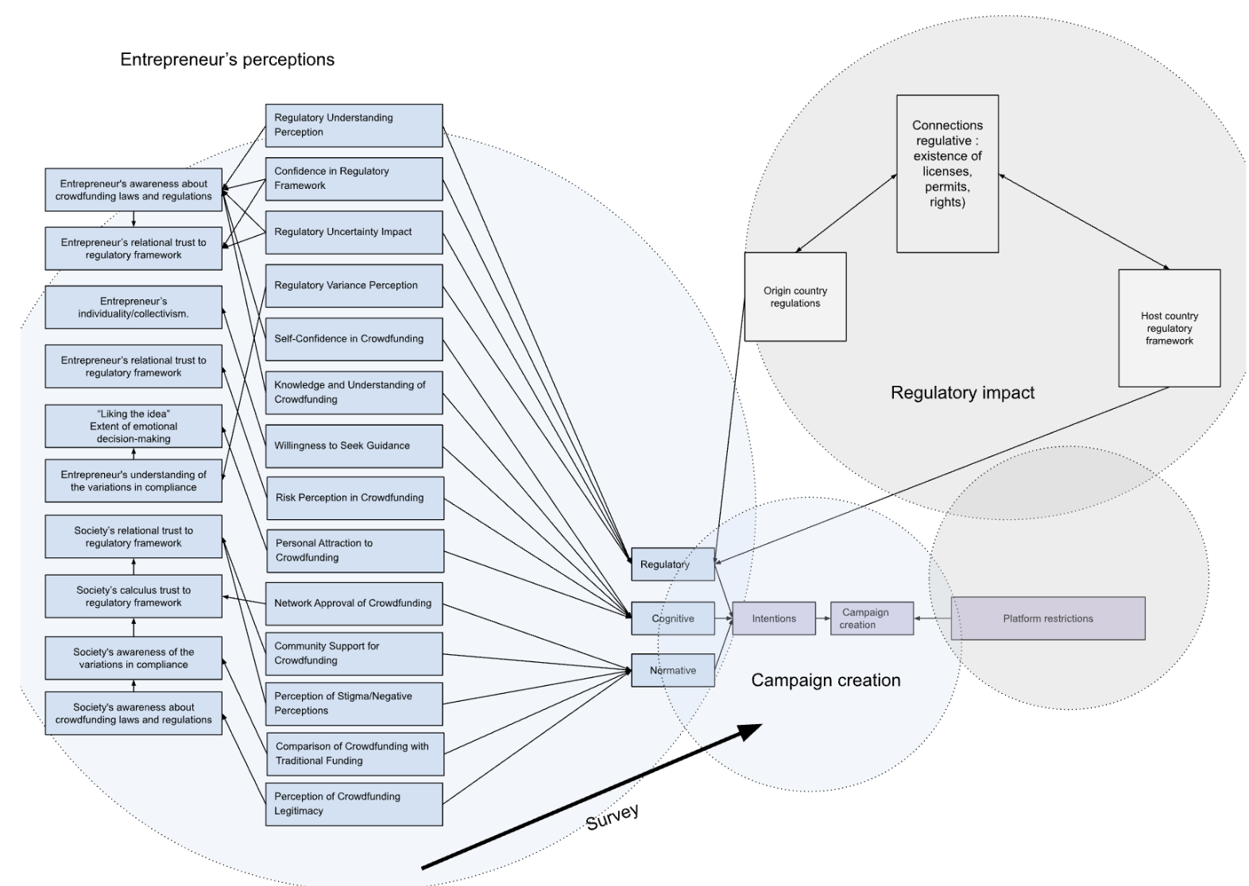
Figure 7: Survey structure, assessment of institutions using the theory of planned behavior
Source: by author

The survey is conducted by snowball sampling method to collect information on over 50 startups located in emerging markets. It encompassed questions regarding their names, technology focus, whereabouts, and different funding sources such as bootstrapping, crowdfunding, loans, government grants, venture capital, and angel investors. The survey included 24 questions measured on a 7-point Likert scale, ranging from 1 (strongly disagree) to 7 (strongly agree), addressing normative, regulative, and cognitive aspects. It consisted of 8 questions, which were a mix of multiple choice and short answer, that covered topics such as geographical region, operational activities, investment amount, and financial data classification. We employed two particular open-ended inquiries to collect data on why an entrepreneur opted for crowdfunding or conventional startup techniques.
The initial part of the survey contains basic details about the startup that needed to be gathered during the internship. The first, second, and third parts consist of details on field, placement, location, startup maturity, funding sources (crowdfunding and traditional methods individually), revenue amount, and guaranteed financing amount. The next section aims to assess how entrepreneurs have utilized various financing methods for their startups, pinpoint specific details, such as the prevalence of crowdfunding in various emerging economies, and delve into open-ended inquiries to comprehend the precise motivations behind choosing crowdfunding over traditional sources of funding.
The next parts consist of three primary categories, which focus on evaluating entrepreneurs' regulatory, normative, and cognitive institutions based on their own perspective.

The questionnaire questions assessing the regulatory institutions includes:
- Entrepreneurs' personal perception of how understandable regulations are and their confidence in being protected by regulatory authorities helps determine the level of complexity they believe they encounter when trying to understand the regulatory framework.
- An entrepreneur's confidence in regulatory protection measures the degree of confidence of individuals in the ability of the current regulatory framework to protect startups involved in crowdfunding, which indicates the level of reliability.
- Examining how uncertainties influence an entrepreneur's actions entails assessing how they respond to shifts in uncertain regulations and circumstances.
- Requesting entrepreneurs to observe discrepancies in regulations between crowdfunding and other methods of funding for startups, assessing their understanding of the variations in compliance.

The assessment of cognitive institutions includes:
- The entrepreneur’s self-assessed confidence in their ability to effectively run a successful crowdfunding campaign for their startups shows us their personal belief in their crowdfunding capabilities.
- The entrepreneur’s perception about their own knowledge and understanding of how crowdfunding works helps us to understand entrepreneur’s self-perceived knowledge in the crowdfunding area.
- The level entrepreneurs seek advice indicates their openness in seeking external support and advice.
- The assessment of an entrepreneur's perception of risk measures the emotional degree of his concern about risks. According to crowdfunding, the higher the emotional perception of risk, the lower the awareness.
- Measuring the level of an entrepreneur's personal interest in using crowdfunding indicates his internal interest in crowdfunding as a source of financing.

The assessment of normative institutions includes:
- Evaluating the entrepreneur's professional network endorsement helps to measure the support for crowdfunding among their professional contacts.
- Assessing the community support of the entrepreneur aids in gauging the support entrepreneurs get from their communities for their crowdfunding efforts.
- Gauging the level of stigma/negative perception present in the community where a startup is based allows us to gain insights into how the entrepreneur may be viewed socially.
- A survey of entrepreneurs to see if they notice any differences in the rules between crowdfunding and other startup financing options, measuring entrepreneurs' awareness of the differences in regularity.
- Investigating how entrepreneur's connections view crowdfunding in contrast to conventional funding options provides insights into public understanding of crowdfunding.
- Evaluating how credible and legitimate crowdfunding is for financing startups in entrepreneurs’ countries helps gauge the level of trust in the regulations of the nation.

Due to the sensitive nature of the data gathered regarding the startup, the survey is carried out in a manner that ensures anonymity.
Secondary data is extracted from crowdfunding platforms (KickStarter, IndieGoGo, etc), with a help to confirm the facts validate, as well as helps to immediately obtain the necessary information. The latest data from entrepreneurship campaigns, which has provided comprehensive knowledge of the latest challenges and trends that have not yet been collected by innovative scientists in the field of entrepreneurship.

3.3 Data analysis
When analyzing the data, we used the method of qualitative comparative analysis of fuzzy sets (fsQCA) because of its suitability for obtaining data of a high degree of complexity and preserving a significant amount of data, allowing for a detailed assessment of the set's membership (Ragin, 2008). fsQCA considers the belonging of phenomena to sets not as absence or presence, but as the varying degree to which they meet the criteria of belonging, ranging from a value of 0 (completely excluded) to a value of 1 (fully included).
For preparation, missing data were eliminated, Likert scale perception was adjusted to adjust the QCA perspective, and unnecessary columns were removed to maintain the quality and reliability of the analysis.
For use in fsQCA, these raw data must be calibrated in the form of fuzzy set membership estimates that express the degree to which cases belong to the set (Schneider & Wagemann, 2012). Calibration is a fundamental operation in fsQCA (Dusa, 2019). In this analysis, we use a direct calibration method (Ragin, 2008), which requires the determination of values corresponding to the qualitative bindings that structure the fuzzy set, namely: set membership (1), set non-membership (0) and the intersection point (0.5).
To calibrate three sets of conditions: REG, NORM, COG, we define qualitative bindings as follows, following the logic of the “intermediate assessment”. Since Likert scores range from 1 to 7, the normative condition is encoded as 0 if the normative value shows a score below or equal to 4 (i.e., an intermediate score between 2 and 6), and as 1 if the normative measurement shows a score above or equal to 4.001 (i.e., an intermediate point between 2 and 6). The same method works with regulatory and cognitive frameworks.
The calibration of measurements is followed by a necessity and sufficiency analysis conducted using the R Studio QCA package (Dusa, 2019).
Acceptance of crowdfunding as the outcome set is coded as 1, while its negation is coded as 0, based on the survey responses.
According to the fsQCA procedure developed by Schneider and Wagemann (2012), each of the analysis steps will be described along with the results in section 4.3.

4. Results

4.1. Survey results
The respondents show more evidence of their lack of understanding about crowdfunding by viewing digital crowdfunding as an equivalent financing method to traditional startup funding methods. Furthermore, over 68.75% of entrepreneurs' plans to utilize crowdfunding are influenced by public opinion. Even though entrepreneurs may have confidence in their cognitive skills, regulatory factors greatly influence the decisions they make related to crowdfunding activities. The information shows that many entrepreneurs do not have a good grasp of the regulatory systems and protections related to crowdfunding in their countries.
The trend of choosing the middle option in questions about understanding and knowledge suggests uncertainty and a lack of awareness. Entrepreneurs have differing opinions on digital crowdfunding as a funding method in comparison to traditional startup financing methods. This shows that many individuals view crowdfunding as a novel method for obtaining funds or are uncertain about its effectiveness compared to traditional methods, underscoring the need for increased education and knowledge in this area. While opinions on the risk of crowdfunding stayed the same, the level of personal interest varied among individuals. Lacking knowledge about crowdfunding and how to address potential challenges can influence how risk is perceived. The findings of the survey show that entrepreneurs often rely on FFF for funding, while crowdfunding is not among the preferred options. This demonstrates a need for security and reliability, which may stem from a lack of understanding of alternate financing options and their benefits.
Most common reasons mentioned about selection of financing methods include the need of reliability, trust, lack of knowledge related to the crowdfunding, uncertainties and time consumption.
According to the survey results, Kickstarter, Patreon, and Indiegogo are the top three most popular crowdfunding platforms in the analyzed emerging economies from the respondent list, with 30 votes for Kickstarter, 18 votes for Patreon, and 13 votes for Indiegogo. The top choice for funding is FFF (Family, Friends and Fools) (27), Loans (16), Venture capital (12), Angel investors (10), Grants (7), Crowdfunding (7), Bootstrapping (4), Accelerators and incubators (4).
From the responses to open-ended questions surveying (a) the reason of using/not using crowdfunding and (b) justification of funding methods selection, the core problem common for most of the entrepreneurs is that the choice to investigate different funding options instead of going with crowdfunding is influenced by multiple factors. First and foremost, considerable time is taken into account while making financing decisions, effort, and resources needed to launch a successful crowdfunding campaign are calculated. For some of the entrepreneurs, a new campaign creation decision fails in the point when startupers realize the risk, or mispercept the reliability of fundraising. Due to restricted bandwidths and concentration on product development, most startups decide to invest existing resources in other aspects of the business that would be more advantageous. Lack of clarity on the results of a crowdfunding effort, risks of failure, the entrepreneurs choose to use alternative funding options like personal savings, loans, and angel investors, which provide with increased control and adaptability that better matched our funding requirements and preferences. Simply put, the choice is primarily connected to their perception of funding methods associated with safety, reliability, and stability.

4.2. Observations from descriptive statistics
The involvement of entrepreneurs from nearly all developed economies that have embraced crowdfunding legally enables us to access relational data directly from the database through descriptive analytics and basic manipulations.
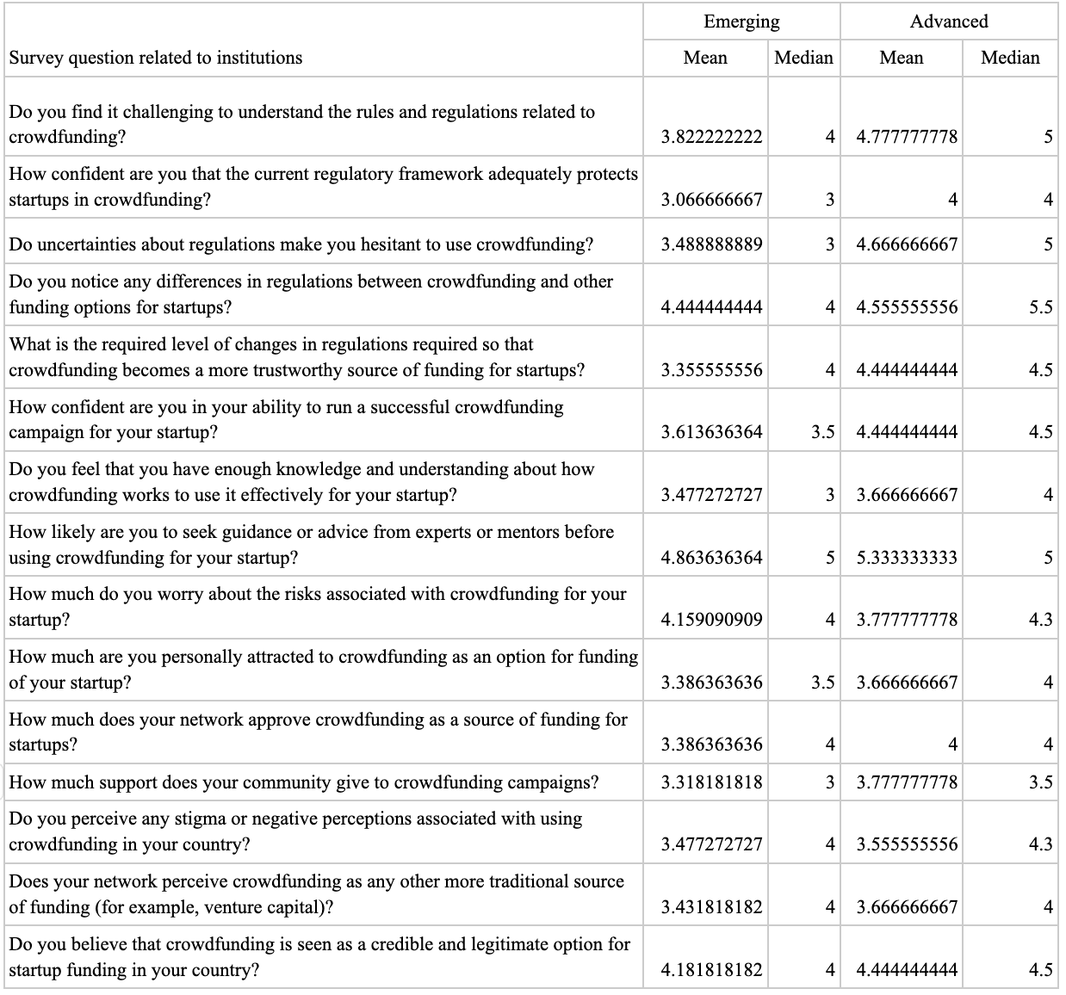
Table 2: Institutional items mean and median value comparison in emerging and crowdfunding-adopted advanced economics based on survey results
Source: Author

From Table 2 it is evident from comparing values that institutions are more developed in advanced economies.
In developed economies in the frames of crowdfunding regulations, entrepreneurs have a higher level of regulatory institution evaluation, indicating that their crowdfunding laws and regulations are well-established, transparent, and easily understood. This fosters trust through awareness of crowdfunding practices, leading to trustworthiness and a strong perception of legitimacy in crowdfunding discussions. This also impacts the emotional views of entrepreneurs as risks, and independence in decision-making, which is leading to confidence in operating within this industry.
In emerging economies, from survey results comes clear that the cognitive abilities of entrepreneurs are not as advanced. Survey results show that in these countries, crowdfunding is seen as dangerous and possibly illegal due to limited individual knowledge. As a result, the perception of risk is heightened, leading to decreased emotional motivation for entrepreneurs.
The normative institutions are also less developed in emerging economies, which indicates that less is perception of dependency from professional networks using crowdfunding as a financing alternative option or not, than less is the probability of individual entrepreneurs using the crowdfunding as a funding source for their startups. The same can be said about community support, the more a society believes in crowdfunding as a reliable source of funding, the more likely entrepreneurs will be inclined to use crowdfunding. And it is quite obvious that in emerging economies, society still lacks knowledge about crowdfunding in general, which affects the level of regulatory institutions in emerging economies and reduces the likelihood that entrepreneurs will use crowdfunding as a method of financing their startups.
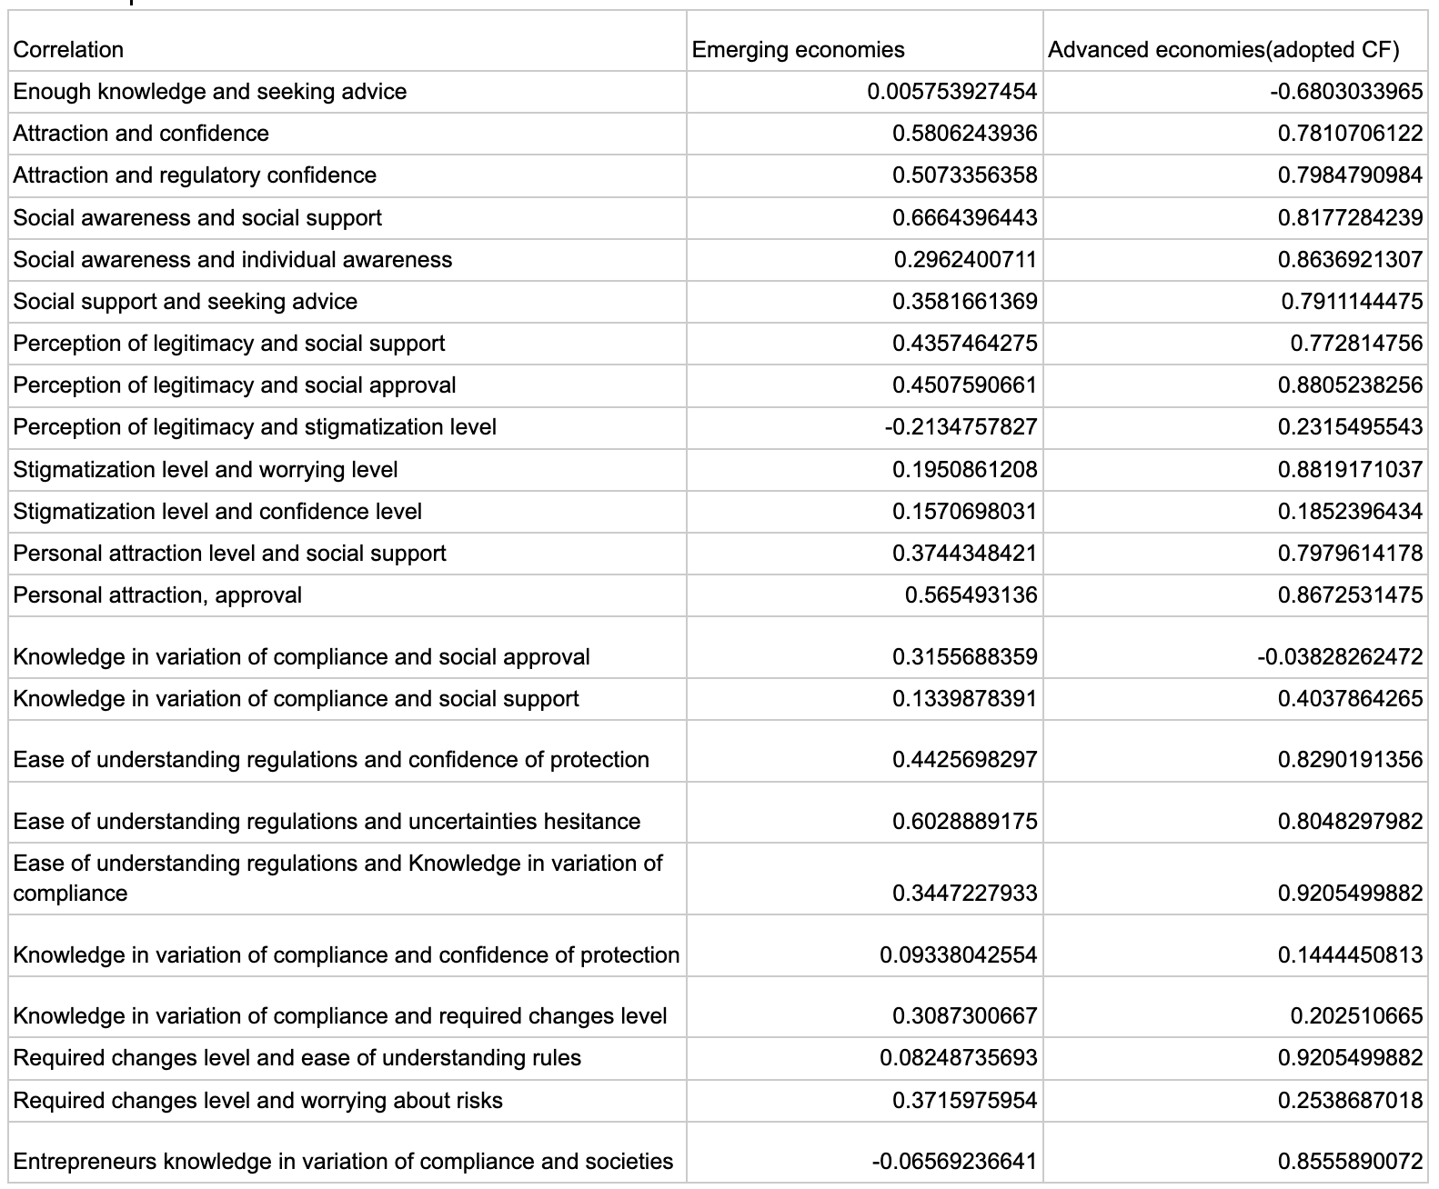
Table 3: The interrelationships of institutional factors in the form of correlations
Source: Author

In advanced economies that have adopted crowdfunding, there is a strong correlation between public awareness of crowdfunding campaigns and the support these campaigns receive, indicating that a well-informed environment that believes in the legitimacy of crowdfunding increases the chances of receiving support from a professional network. Similarly, the higher the public's awareness of crowdfunding practices, the more crowdfunding is accepted. In emerging economies, the relationship between normative influence and normative trust is less significant.
Speaking about the normative impact on the cognitive institutions of entrepreneurs, it is worth noting that no significant, in fact weak positive correlation was found between anxiety and stigmatization accepted in the norms. Similarly weak positive correlation is found between stigmatization accepted in the norms and entrepreneurs confidence in using crowdfunding. Thus, in general terms, stigmatization does not affect the willingness of entrepreneurs to create new campaigns in either emerging or advanced economies. On the other hand, a strong positive correlation was found between the personal interest of entrepreneurs in using crowdfunding and public support. This means that the higher the trust and attractiveness of entrepreneurs in using simple financing, the more likely it is that an entrepreneur will receive the approval of the society of the country in which the startup operates.
Another strong positive correlation showing the cognitive institutions impact on the normative one is as more is entrepreneurs' perception that they have enough knowledge to operate a new crowdfunding campaign then less likely are they too sick and advice and support from the society. So, we may conclude from here that entrepreneurs' cognitive institutions have a greater impact on how society views and stigmatizes/legitimizes crowdfunding campaigns than norms on the cognitive institutions. It is important to point out that the correlation is stronger in individualistic countries, indicating a stronger connection in advanced economies and a somewhat weaker but still notable connection in less advanced ones. So, we may conclude that as high is the influence of cognitive dimension on the entrepreneur, as less is normative pressure on the new venture creation.
A strong positive correlation was found between the perception of standards regarding the regulatory framework supporting crowdfunding and personal attractiveness: if an entrepreneur believes that the regulatory environment in one’s country is conducive to crowdfunding, one is likely to be interested in using crowdfunding. Just as an entrepreneur may be attracted to the idea of crowdfunding, one’s interest in creating new companies is most likely reinforced by the belief that the regulatory framework will protect their efforts. It is worth noting that the correlation is stronger in advanced economies. This clearly indicates confidence in calculations and confirms the idea of high correlation in advanced economies, similarly, the average correlation in emerging economies indicates a predominance of relational trust. Strong positive correlation is observed in developing countries, providing evidence for this statement, while in developed countries the correlation is even stronger.

4.3. QCA results

Although a necessary condition alone may not lead to the outcome, it is always present when the outcome occurs, encompassing all possible outcomes. In accordance with Schneider and Wagemann (2012) guidelines, we established a consistency threshold of 0.9 and a necessity relevance threshold of 0.6 to determine truly significant necessary conditions for the desired outcome.
A sufficient condition is one that results in the desired outcome. Put simply, if a sufficient condition exists, the result will follow (meaning the sufficient condition is part of the result). Examination of sufficiency relationships is aided by the utilization of truth table analysis and logical minimization algorithms to determine the smallest combinations of conditions that are necessary for the desired outcome. If a specific condition exists, the result will also exist (meaning that the condition is part of the result). Examination of sufficiency relationships is aided by the utilization of truth tables and logical minimization algorithms, which are essential for determining the smallest set of conditions needed to achieve the desired outcome. We set the consistency threshold at 0.8, and PRI (Proportional Reduction in Inconsistency) at 0.7.

truthTable(DATA, outcome = "D", conditions = "A, B, C", incl.cut = 0.8, pri.cut = 0.7, show.cases=TRUE, sort.by = "incl,n+")
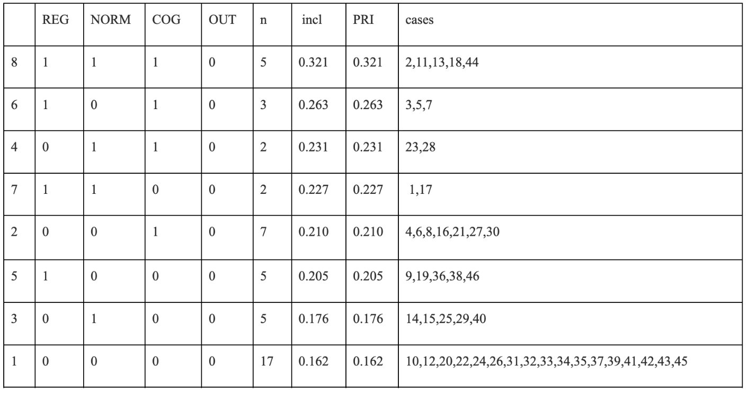

Table 4: The truth table D
Source: Author

Table 4 displays a truth table for a DATA dataset containing four variables: A, B, C (respectively REG, LOG, NORM), and CF. The variable CF is produced, indicating the utilization of crowdfunding. The calibrate function uses the thresholds argument to set thresholds for every independent variable. Column n displays the count of observations in the dataset that meet the criteria of the rule. The argument inclusive.cut determines the minimum value required for a rule to be included in the truth table based on the inclusion measure. The pri.cut parameter sets the lowest allowed priority index value for a rule to be considered in the truth table.
Based on the research by Schneider and Wagemann (2012) and Greckhamer et al. (2018), the frequency threshold is set as one instance in the setup, with the consistency threshold at 0.8 and the PRI threshold at 0.7.
The show.cases parameter determines if observations meeting the rule's conditions should be displayed or not. The value of the result variable for each combination of independent variable values is shown in the OUT column. In this instance, the result variable is D, a binary variable with values of 0 and 1. We define the sorting criteria for the rules. The sort.by parameter: "incl,n+" includes sorting by inclusion, followed by the number of positive observations.
From the table results, it is evident that the inclusivity index is well below the thresholds even in the initial rows, showing a negative outcome, indicating that no solutions are present in this section. This indicates that there are no groups exerting influence over the utilization of crowdfunding for adoption. This indicates that the study group has not completely grasped crowdfunding yet. This is expected in our dataset, as some participants reported using crowdfunding but only reached a maximum consistency threshold of 0.3, well below the ideal 0.75. We could argue that there are no institutional-level factors affecting the decision to use crowdfunding for creating new campaigns. While the literature recommends a consistency threshold of 0.75, we opt for 0.8 to achieve stricter results.

> truthTable(DATA, outcome = "~D", conditions = "A,B,C", incl.cut = 0.8, pri.cut = 0.7, show.cases=TRUE, sort.by = "incl,n+")

We called the neglect table, to see the corresponding values for the negated outcome variable (~D). For initial results, the same rules and arguments are given.

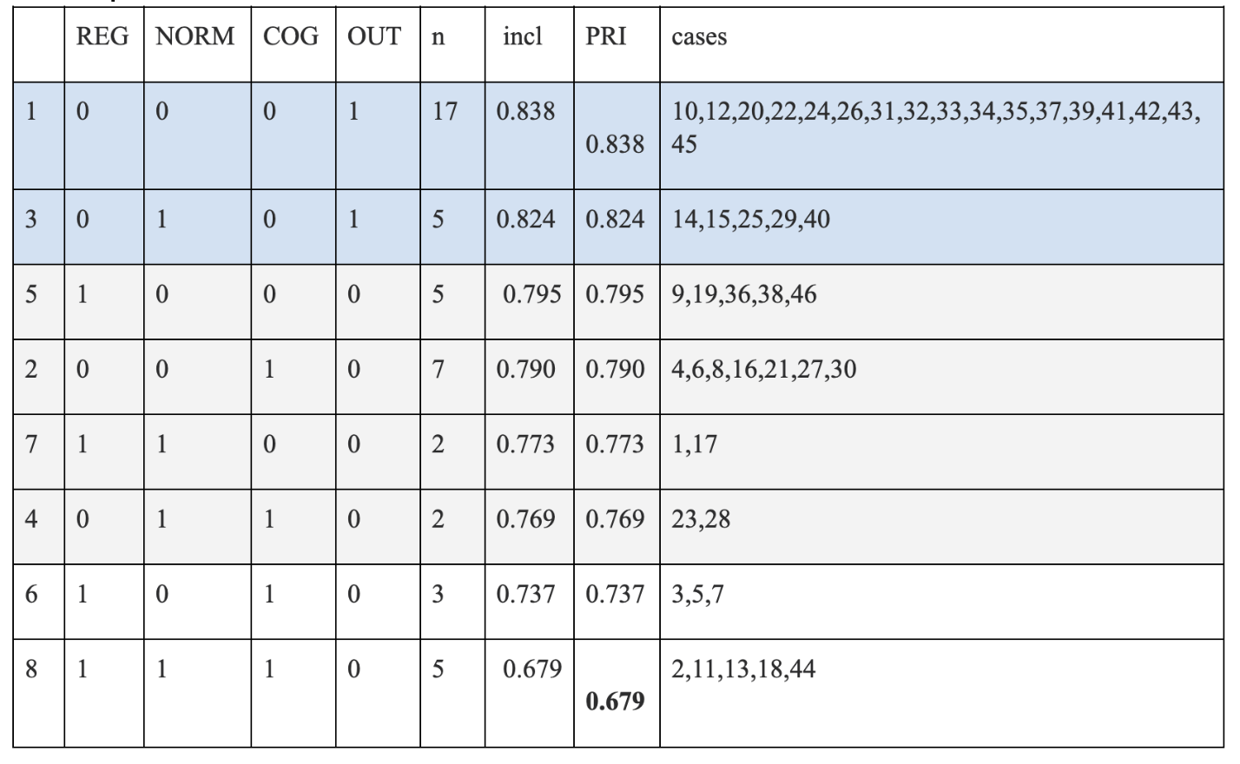
Table 5: The truth table neglect D, inclusivity cut 0.8
Source: Author

If we put the value for inclusivity cut 0.8, we can see two positive results displayed on the truth table. (a) The first result indicates three false values given to the institutions. This outcome covers 17 negative cases in the dataset. (b) The second result indicates two false values from regulative and normative institutions, and true value from the cognitive institution. This outcome covers 5 negative cases in the dataset.
- Poor cognitive, normative and regulatory institutions are prohibitors of crowdfunding adoption in emerging economies.
- Poor normative and regulatory institutions are prohibitors of crowdfunding adoption in emerging economies.

These two factors together are testing and confirming hypothesis 2, which says “Cognitive dimension does not act as an inhibitor of adoption of crowdfunding in emerging economies. “

By reducing additional configurations, such as A or C not being present results in

~A*~C -> ~D.

By setting a consistency level of 0.75, we are causing the factors to operate independently. If the regulatory level is set as law, then crowdfunding adoption will be minimal. Whether regulation or cognition is developed, if norms are low, crowdfunding adoption will be low.If we lower the value for inclusivity cut to 0.75(accepted standard), we will have (c) four more results allowing us to gain insights from independent institutions which inhibit crowdfunding adoption in emerging economies. For instance, a strong Regulatory/Cognitive institution independently is not a prerequisite of crowdfunding adoption. The factors only work together, which is confirming Hypothesis 1 as is evidence from the results, which is saying “Regulatory, cognitive or normative institutions do not influence independently on adoption of crowdfunding in emerging economies.”.

The minimization function can discover a group of rules that encompass all situations in the dataset, regardless of whether the rules meet the designated values for inclusion or priority limitations. On the flip side, the super Subset function only gives back rules that meet the exact values of the inclusion limitation and priority. If there are no rules that match these restriction values, an error message will be returned by the super Subset function. The superSubset function identifies rules in the dataset with an inclusion score meeting the specified cut-off value and a priority score meeting the specified cut-off value.
> minimize(LOW, details = TRUE, show.cases = TRUE)
M1: ~A*~C -> ~D
inclS PRI covS covU cases
--------------------------------------------------------------------------------------------------------
1 ~A*~C 0.836 0.836 0.486 - 10,12,20,22,24,26,31,32,33,34,35,37,39,41,42,43,45; 14,15,25,29,40
--------------------------------------------------------------------------------------------------------
M1 0.836 0.836 0.486

The code results indicate that the key rule in predicting variable D is when both A and C are false, then D is also false. This means that poorly developed regulatory and cognitive institutions are the main inhibitors of crowdfunding adoption in emerging economies. The rule receives a high level of inclusion, priority, and coverage scores.
> minimize(LOW, include = "?")
M1: ~A*~C -> ~D
> superSubset(DATA, outcome = "D", incl.cut = 0.9, ron.cut = 0.6)
Error:
There are no configurations, using these cutoff values.
> superSubset(DATA, outcome = "~D", incl.cut = 0.9, ron.cut = 0.6)
Error:
There are no configurations, using these cutoff values.

From Subset function results, it becomes clear that inadequate regulation and norms result in minimal use of crowdfunding. The factors are mutually enhancing each other.
The coverage is overwhelming, nearly half of the responses validate the suggestion, we can't ask for more. This discovery results from two setups, both of which encompass the majority of. Inadequate regulation and norms are enough to prevent adoption. There are certain factors that are causing issues when it comes to creating campaigns and are causing them to fail.
Analysis of sufficiency confirms our previous discovery that a well-developed regulatory framework drives the adoption of crowdfunding campaigns, which validates the previously identified hypotheses.
The study's analysis revealed that both regulatory and normative institutions work together to hinder the growth of crowdfunding. This indicates that addressing both regulatory and normative factors is necessary to encourage the adoption of crowdfunding. This point is confirming our last third Hypothesis saying “Poor development of regulatory and normative institutions is the key inhibitor of adoption of crowdfunding in emerging economies.”
To sum up, the results of QCA analysis are bringing us the evidence of the hypotheses generated on the theory base. Based on these results, we have gained four valuable insights for emerging economies, which are showing the institutional influence and reasons of adoption/non-adoption of crowdfunding and new ventures creation:
- Regulatory, cognitive or normative institutions do not influence independently on adoption of crowdfunding in emerging economies.
- Cognitive dimension does not act as an inhibitor of adoption of crowdfunding in emerging economies.
- Poor development of regulatory and normative institutions is the key inhibitor of adoption of crowdfunding in emerging economies.
- there are no institutional-level factors affecting the decision to use crowdfunding for creating new campaigns.

5. Discussion

5.1. Institutions impact on adoption of crowdfunding in emerging economies
The findings of this study are consistent with the existing literature on crowdfunding in emerging markets, and are serving as a comprehensive summary of the analysis done before with the extensive and descriptive nature. Previous studies have found that entrepreneurs in emerging markets face a number of challenges in accessing crowdfunding, including lack of awareness, lack of trust, and regulatory barriers. The lack of regulatory guidance on crowdfunding, and especially equity crowdfunding, is likely to hinder the industry's growth and prospects. (Suresh et al., 2020)
In developed economies, entrepreneurs are subject to thorough evaluation by regulatory institutions within the context of crowdfunding regulations, signaling that their crowdfunding laws are robust, clear, and comprehensible. This affects how entrepreneurs feel emotionally by factoring in risks and freedom in decision-making, ultimately boosting confidence in navigating this sector. An informed setting that values the legitimacy of crowdfunding boosts the likelihood of getting support from a network of professionals.
According to the survey results, in emerging economies, all three institutions: cognitive, normative and regulative, are less advanced as in crowdfunding-adopted countries. Crowdfunding is seen as dangerous and possibly illegal due to limited individual knowledge. Here, the perception of risk is heightened, leading to decreased emotional motivation for entrepreneurs. Society still lacks knowledge about crowdfunding in general, which is increasing stigma, and decreasing acceptance and support. But here, if an entrepreneur believes that the regulatory environment in one’s country is conducive to crowdfunding, one is likely to be interested in using crowdfunding. Here financing decisions consider time, effort, and resources required to start a successful crowdfunding campaign. Some entrepreneurs may see their new campaign plans falter when they become aware of the potential risks or misunderstand the trustworthiness of fundraising. The choice of funding method is primarily connected to their perception of funding methods associated with safety, reliability, and stability. Weak knowledge and understanding as a root problem of uncertainty perception, risk perception level, lack of trust to legitimacy and reliability.
Survey results also highlight several additional valuable considerations, such as time being taken into account while making financing decisions, effort, and resources needed to launch a successful crowdfunding campaign are calculated. Often new campaign creation decisions fail at a point of failure, risk realizing, or misperception the reliability of fundraising. Due to restricted bandwidths and concentration on product development, most startups decide to invest existing resources in other aspects of the business that would be more advantageous. Lack of clarity on the results of a crowdfunding effort, risks of failure, the entrepreneurs choose to use alternative funding options like personal savings, loans, and angel investors, which provide with increased control and adaptability that better matched our funding requirements and preferences. Simply put, the funding choice is primarily connected to their perception of funding methods associated with safety, reliability, and stability.
Three of the most important conclusions are: (a) Regulatory, cognitive or normative institutions do not influence independently on adoption of crowdfunding in emerging economies. (b) Poor development of regulatory and normative institutions is the key inhibitor of adoption of crowdfunding in emerging economies. (c) Cognitive dimension does not act as an inhibitor of adoption of crowdfunding in emerging economies.

5.2. New ecosystem and perspective for digital crowdfunding 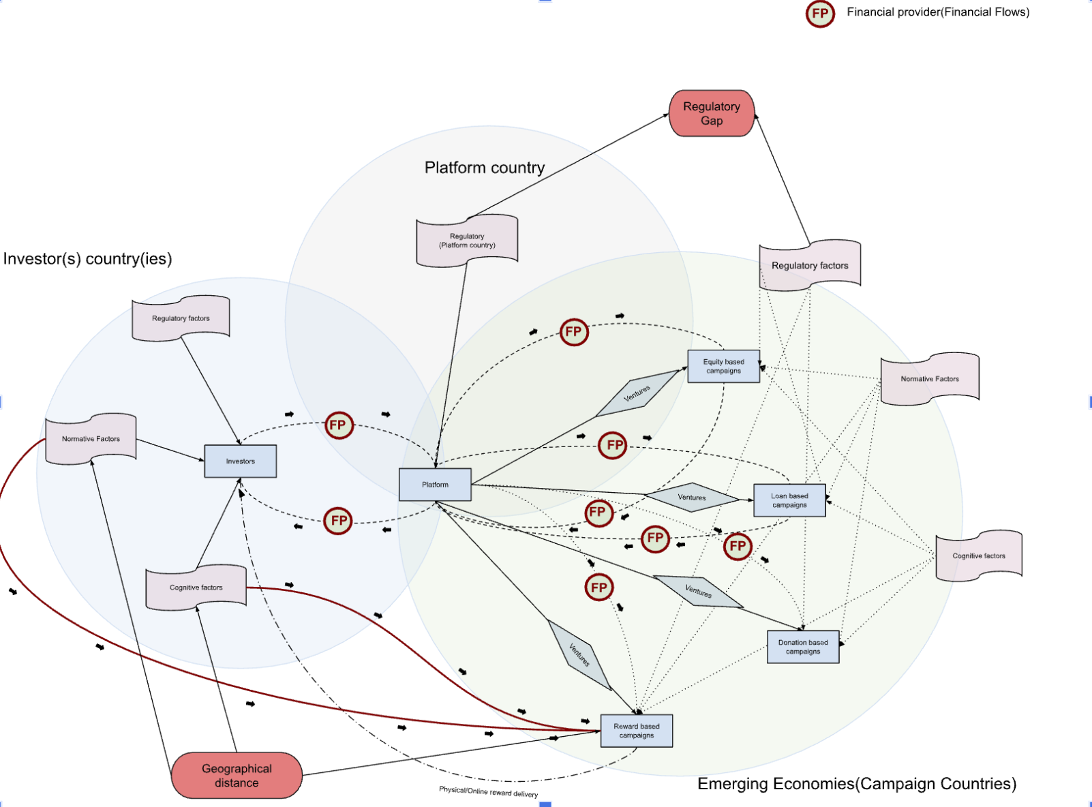
Figure 6: Institutions impact on the Crowdfunding Ecosystem in Emerging Economies by author

Based on crowdfunding reviews ecosystems and process capturing made by several authors, a new ecosystem is drawn during research which serves as an extension of all of the existing literature including institutional impact on the ecosystem from a multi-dimensional view. This means that the system is not considered separately for tree stakeholders but from an international point of view considering the three parties may have different institutions which may influence the single ecosystem from different perspectives and provide risks and uncertainties for all of the parties involved. Also the ecosystem involves different business models flows separately which allows to get as precise as assumptions and suggestions as possible.
The main suggestions that became clear after the extension was made is that while considering the paths and patterns related to the inhibitors of crowdfunding adoption in emerging economies, not only campaigners country regulatory system and institutions influences should be taken into account but also the platforms country regulative institutions. Similarly, while considering platform expansion to the new markets, the gap size also has huge significance here as financial intermediaries such as crowdfunding platforms may have huge risks connected with the financial losses.
The most important findings related to regulatory institution influence on the unavailability of crowdfunding adoption in new emerging markets here include but are not limited to: (a) The greater the gap between regulatory systems in developing countries (campaign) and in developed countries(platform), the less likely it is to create new campaigns. (b)The smaller the gap between regulatory systems in developing countries (campaign) and developed countries(platform), the more likely it is to create new campaigns. (c)As developed is the regulatory system in a country, as higher is cognitive factor influence on the new ventures creation(campaigns).
The most important finding related to the normative and cognitive institutions influence on the crowdfunding campaigns creation to be more precise to unavailability of new companies creation include following: As high is the influence of cognitive dimension on the entrepreneur, as less is normative pressure on the new venture creation, and vice versa. (campaigns)
And the last assumption that is found from here related to the institutions is pretty confirming the results coming from the research results which indicates the reliability of the finding suggest that in emerging economies where the regulatory system is less developed, and there are less normative pressures according to campaign creation, emotional incentives are the main drivers for entrepreneurs in cognitive pillar to create new campaigns. (campaigns)
Ecosystem drone also found that in the case if the startup business model is reward based We're the product to be delivered to the early client from a third country which is investors country, several more factors appear because the regular flow is being added to the vouching of the production. Therefore, considering this fact several more issues may arise here such as primary understanding that crowdfunding campaign creation and success is depending not on the factors determined throughout the analysis but also including the normative and cognitive institutions pressure from the investor side which is usually indicating the Third Country pressure. Namely when taking the decision invest or non-invest, the investor is relying on the institutions of investor side country, cultural differences, region specific needs and geographical distance are influencing on the investors intention to fund the startups from Imaging economies and by this also may be explained the tendency of new campaigns from emerging economies to fail.

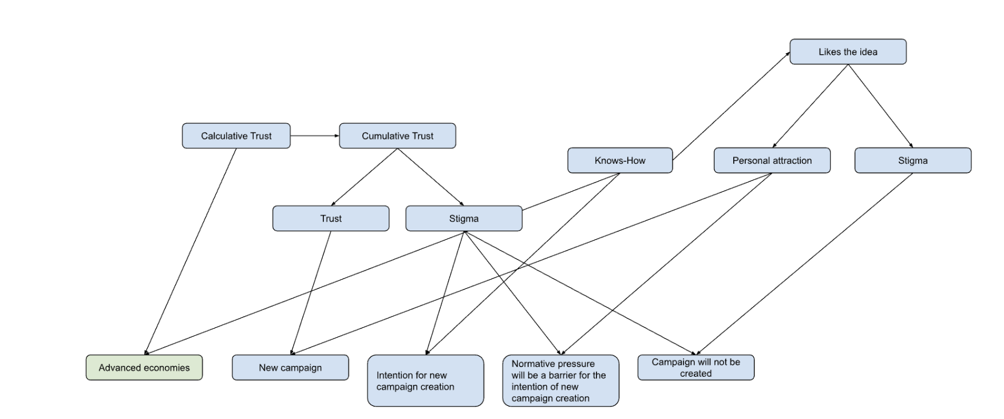

Figure 7: Plan behavior theory expansion for determining the entrepreneurs intention to create new campaign in emerging markets: cases discussion

Following figure is expanding the plane Behavior Theory into crowdfunding entrepreneurial decision Theory by getting the emotional and knowledge-based factors influences on the entrepreneurs cognitive abilities and highlights all of the possible cases Could take a place depending on the factors affection solely or with complementing each other.
The diagram shows that if the calculated trust of society is high, and the knowledge of the entrepreneur is high, then there are no gaps in the regulatory framework. Three assumptions are taking place to be considered in future research: (a) Society trusts CF, but entrepreneurs do not, society impacts on entrepreneurs by norms, and new campaigns will be created. (b )If society has stigma to CF, but entrepreneurs do have high awareness, and high confidence about campaign creation, despite normative pressure, the campaign is likely to be created. (c) If society feels stigma to CF, and entrepreneurs do also have stigma to CF, the intention to create campaigns will be canceled.

6. Conclusions

6.1. Contribution to research
Typically, theory examines crowdfunding campaigns from a singular viewpoint, either by analyzing each step of the crowdfunding process individually or taking a broader view from the ecosystem perspective. Lehner's ecosystem focuses on the viewpoints of three stakeholders but fails to investigate global instances to better understand the impact of institutions on crowdfunding campaigns from the perspectives of campaigners, platforms, and backers. Equally important is having different viewpoints on the different types of campaigns. The study undertaken presents a novel ecosystem framework that encompasses three stakeholders involved in the crowdfunding process. It looks at institutional impacts from three distinct viewpoints and emphasizes the interaction among regulatory, normative, and cognitive influences on a worldwide scale. It also explores the unique attributes of each crowdfunding type, allowing for a thorough grasp of how these platforms and campaigns function in emerging nations. Through this in-depth examination, patterns linking different process elements and institutions can be evaluated and identified, providing a more detailed understanding of the entire system. The ecosystem was developed in compliance with existing regulations in platform and campaign countries. Future research could explore modern digital technologies, like smart contracts, as alternatives to traditional financial providers.

Previous research within the framework of institutional theory has looked at crowdfunding operations either from an institutional point of view, namely how institutions individually influence entrepreneurial behavior, but there are very few studies showing the exact relationship between individual studies, and there is no clear answer to the question of how institutions influence each other and how they influence entrepreneurial behavior in emerging economies. Knowing the specifics of developing new campaigns, how important the factors influencing decision-making processes for developing new campaigns are, and, most importantly, identifying dominant and recessive factors affecting emerging markets specifically, will allow us to understand exactly what actions need to be taken in the future. to solve the problem of low entrepreneurial activity in emerging market countries. In this study, we have made an important conclusion by going beyond the institutional framework. We found that the creation of new campaigns in emerging markets is particularly influenced not by the regulatory framework of the country of origin of the platform or the country of the campaign participant, but by the difference between the regulatory systems of the two countries. Additionally, a key discovery from this study was the limited influence of cognitive institutions on the development of new campaigns. This indicates that future researchers should consider minimizing the importance of cognitive research and instead prioritize normative and regulative institutions. Therefore, we encourage future researchers to continue to analyze gaps in legislation in emerging economies, rather than the regulatory system of the emerging country in frames of which the startup operates.

The impact of the institutional environment varies on various types of business models for new crowdfunding campaigns. While this is a well-studied concept in institutional theory literature, our study shows that the influence is particularly strong on reward-based crowdfunding campaigns, affecting both the entrepreneur's and international investors' normative and cognitive institutions. Hence, examining both viewpoints assisted us in determining the factors that could lead to potential failures in new crowdfunding campaigns in developing markets, highlighting the importance of investigating the reasons for unsuccessful campaign operations.The success of reward-based crowdfunding primarily relies on investor motives, so we recommend focusing future research on evaluating investor demographics instead of campaign creators during the campaign.

Another important contribution is confirming the validity of the research done previously by theoretics by surveying individual startupers in the real-life perspective by giving accurate and freshest information about crowdfunding state in emerging economies.

6.2. Practical implications

Crowdfunding platforms
The research carried out could be used as a blueprint for Crowdfunding platforms looking to widen their reach into different markets as alternative finance intermediaries. Crowdfunding platforms are not entering new emerging markets due to challenges with regulatory disparities that safeguard the rights of financial intermediaries. The primary cause is that platforms are encountering risks in the form of significant financial losses. For example, the study orients existing platforms available for licensing under the recent EU ECSPR(European Crowdfunding Service Provider Regulation) system, allowing for the expansion into untapped emerging markets within the EU, as well as for creation of new campaigns. It also highlights the importance of being aware of potential regulatory risks in these emerging economies. Research also allows new platform creators to more effectively position themselves in markets they depend on.

Entrepreneurs(Campaigners)
This study could serve as a valuable resource for entrepreneurs interested in creating campaigns, educating them on regulations and important aspects to keep in mind. This study serves as a comprehensive guide containing essential information for both campaigners and investors to gain a thorough understanding of crowdfunding processes, stakeholders involved, opportunities, and potential risks involved in the campaign. The study seeks to raise awareness among developing countries about the specific details of digital crowdfunding, with the goal of enhancing normative and cognitive processes by motivating them to engage in the creation of new campaigns. As our findings indicate that in countries with well-established normative institutions rooted in truth and knowledge, crowdfunding campaigns are more likely to successfully secure funding for their startup projects.

Policy Makers
As mentioned earlier, we discovered the importance of creation of new crowdfunding service providers creation or adoption in the countries in order to minimize the gap between the regulatory systems of campaigner and platform countries, and to make some clearance for entrepreneurs in order to better understand regulatory system appearing as a confirmation of legitimacy of the platform, increase awareness about how the system protects the entrepreneurs rights, and what obligations exist. The crowdfunding service provider should manage the regulation process of all the steps necessary for campaign creation and operation, including advertising practices, and serve as a reliable organ for entrepreneurs to trust. So overall, this study aims to increase trust related to the crowdfunding practices in emerging economies, so policymakers could implement separate authority creation, adopting international standards of crowdfunding linked to the inner low system of a country.

Researchers
This study offers researchers a significant opportunity to contribute to regulatory framework analysis in various economies, including identifying gaps and analyzing patterns in this field. This orientation could be the main tool to address the research problem of the challenge regarding the use of crowdfunding in developing countries. Apart from that, there is a need for technological research to gain a better understanding of how digital technologies are impacting financial providers. This is necessary for expanding the ecosystem that was created during the study on crowdfunding in emerging economies. Even though the modern world has undergone significant changes in the era of Technological Revolution 5.0, the exact ways in which digital technologies will alter the ecosystem are still being explored.

6.3. Limitations and future research
As mentioned above, this paper suggests future researchers focus on three main areas: regulatory research on laws across different countries to reduce risks, technological research on how digital technologies affect financial providers, analyzing crowdfunding in emerging economies with a focus on failure cases.
The initial limitation of our research conducted is the list of developing countries. As mentioned earlier, we used the latest information from the World Economic Outlook database in 2023 for developing and emerging nations. Nevertheless, in certain countries, economic conditions are rapidly getting better, hence sporadic validation checks will be required while initiating new research avenues. The second restriction involves nations included in the study. We have data from a very limited list of countries, overall 17 out of 160 developing countries, namely from Armenia, Georgia, Russia, Uzbekistan, Pakistan, Serbia, Bulgaria, Sri-lanka, India, Indonesia, Vietnam, Peru, Mexico, Ethiopia, Nigeria, Uganda and Ghana, also almost from all advanced countries, in where crowdfunding is supported by all institutions, namely Germany, UK, UAE, Lithuania, and Norway. We have studied nearly all regions with similar cultures and collected data from every continent worldwide, but this hinders our ability to assess certain culture-specific aspects of legitimacy for countries not included in our list of campaign countries. However, our research saves as a base for further analyses, but one should consider gathering secondary data additionally, while opening up new perspectives in examining crowdfunding in emerging economies.
The second major limitation concerns how new digital technologies are affecting crowdfunding in today's world. The theory on the impact of digital technologies on crowdfunding is still in its early stages. More in-depth technological knowledge is required to make assumptions about how modern technologies affect the creation of online campaigns and financial flows. Due to technological advancements, fundraising without traditional financial intermediaries like crowdfunding platforms is possible, but this leads to conflicts and gaps in terms of legitimacy and regulatory protection for investors and campaigners. A deeper grasp of the different facets of financial flows is necessary, given their greater volatility compared to conventional financial institutions. We recommend creating a dedicated analysis of these technologies, as current academic and institutional research does not fully grasp how these technologies could potentially replace traditional financial services.

6.4. Final remarks
In developed economies, entrepreneurs are subject to thorough evaluation by regulatory institutions within the context of crowdfunding regulations, signaling that their crowdfunding laws are robust, clear, and comprehensible. This affects how entrepreneurs feel emotionally by factoring in risks and freedom in decision-making, ultimately boosting confidence in navigating this sector. An informed setting that values the legitimacy of crowdfunding boosts the likelihood of getting support from a network of professionals.
In emerging economies, all three institutions: cognitive, normative and regulative, are less advanced as in crowdfunding-adopted countries. Crowdfunding is seen as dangerous and possibly illegal due to limited individual knowledge. Here, the perception of risk is heightened, leading to decreased emotional motivation for entrepreneurs. Society still lacks knowledge about crowdfunding in general, which is increasing stigma, and decreasing acceptance and support. But here, if an entrepreneur believes that the regulatory environment in one’s country is conducive to crowdfunding, one is likely to be interested in using crowdfunding. Here financing decisions consider time, effort, and resources required to start a successful crowdfunding campaign. Some entrepreneurs may see their new campaign plans falter when they become aware of the potential risks or misunderstand the trustworthiness of fundraising. The choice of funding method is primarily connected to their perception of funding methods associated with safety, reliability, and stability. Weak knowledge and understanding as a root problem of uncertainty perception, risk perception level, lack of trust to legitimacy and reliability.
The results of QCA analysis are bringing us the evidence of the hypotheses generated on the theory base. Based on these results, we have gained four valuable insights for emerging economies, which are showing the institutional influence and reasons of adoption/non-adoption of crowdfunding and new ventures creation:
Regulatory, cognitive or normative institutions do not influence independently on adoption of crowdfunding in emerging economies.
Cognitive dimension does not act as an inhibitor of adoption of crowdfunding in emerging economies.
Poor development of regulatory and normative institutions is the key inhibitor of adoption of crowdfunding in emerging economies.
there are no institutional-level factors affecting the decision to use crowdfunding for creating new campaigns.

References
(2020). In R. Shneor (Ed.), Advances in Crowdfunding: Research and Practice. Springer International Publishing. https://doi.org/10.1007/978-3-030-46309-0_1
Advances in Crowdfunding Research and Practice. (n.d.). R. Shneor et al. https://doi.org/10.1007/978-3-030-46309-0_13
Alhammad, M. M., AlOthman, R., & Tan, C. (2021, Dec 02). Review of Crowdfunding Regulations across Countries: A Systematic Review Study. Journal of Information Systems Engineering and Management, 6(4). https://doi.org/10.21601/jisem/11395
Assadi D. (2018). Crowdfunding: democratizing networking, financing and innovation. Journal of Innovation Economics & Management,, 26, 3-12. https://doi.org/10.3917/jie.026.0003
Beugre, C. (2014, October 20). The Legitimacy of Crowdfunding: An Institutional Theory Perspective. Academy of Management Proceedings, 2014. researchgate. DOI:10.5465/AMBPP.2014.10611abstract
Block J. H., Colombo M. G., Cumming D. J., & Vismara S. (2018). New players in entrepreneurial finance and why they are there. Small Business Economics, 50(2), 239–250. http://www.jstor.org/stable/44697250
Blohm, I., Haas, P., & Jan Marco Leimeister. (2014, December). An Empirical Taxonomy of Crowdfunding Intermediaries. ResearchGate. Retrieved April 21, 2024, from https://www.researchgate.net/publication/265844619_An_Empirical_Taxonomy_of_Crowdfunding_Intermediaries
Bouba, I. (2023, July 17). The state of crowdfunding in Africa and its potential impact: a literature review. ResearchGate. Retrieved May 12, 2024, from https://www.researchgate.net/publication/372730558_The_state_of_crowdfunding_in_Africa_and_its_potential_impact_a_literature_review
Bradford, C. S. (2012, March 09). Crowdfunding and the Federal Securities Laws. Columbia Business Law Review.
Brem, Bilgram, A., Marchuk, V., & z. (2019). How crowdfunding platforms change the nature of user innovation – from problem solving to entrepreneurship,. Technological Forecasting and Social Change, Elsevier,,, 144(C), 348-360.
Bruton, G. D., Ahlstrom, D., & Li, H.-L. (n.d.). Institutional Theory and Entrepreneurship: Where Are We Now and Where Do We Need to Move in the Future? Entrepreneurship Theory and Practice, 34(3), 1042-2587. https://doi.org/10.1111/j.1540-6520.2010.00390.x
Business model innovation and Industry 5.0: a possible integration in GLAM institutions. (2009, June 3). European Journal of Innovation Management. Retrieved March 12, 2024, from https://www.emerald.com/insight/content/doi/10.1108/EJIM-09-2023-0825/full/html
C., Hörndlein.,, Alexander, Benlian., & Thomas, Hess. (2012). Institutional Influences in Individual-level Innovation Adoption outside Organizational Contexts: A Scale Development Study. Research Papers in Economics.
Cavallo, A. (2024, January 8). Call for papers (A. M. Petruzzelli, M. Holgersson, S. Heaton, U. Panniello, V. v. d. Vrande, & M. G. Colombo, Eds.). Techinovation,, 3(SI), 3. https://www.sciencedirect.com/journal/technovation/about/call-for-papers
Challenges and opportunities for crowdfunding in emerging markets: an ethical perspective. (2022). In D. K. Nguyen (Ed.), Handbook of Banking and Finance in Emerging Markets. Edward Elgar Publishing.
Chalmers, D., MacKenzie, N. G., & Carter, S. (2021). Artificial Intelligence and Entrepreneurship: Implications for Venture Creation in the Fourth Industrial Revolution. Entrepreneurship Theory and Practice, 45(5), 1028-1053. https://doi.org/10.1177/1042258720934581
The Contribution of Crowdfunding Regulation to Cultural Entrepreneurship in a Supportive Ecosystem. (2021). In P. Demartini, L. Marchegiani, M. Marchiori, & G. Schiuma (Eds.), Cultural Initiatives for Sustainable Development: Management, Participation and Entrepreneurship in the Cultural and Creative Sector. Springer International Publishing.
D., C., N. G., M., & Carter, S. (n.d.). Artificial Intelligence and Entrepreneurship: Implications for Venture Creation in the Fourth Industrial Revolution. Entrepreneurship Theory and Practice, 45(5), 1028-1053. https://doi.org/10.1177/1042258720934581
Daxin, Sun., Yaxin, Zhang., Xiaohua, & Meng. (2023). Green side of informal institutions: Social trust and environmental sustainability. Business Ethics, the Environment and Responsibility. doi: 10.1111/beer.12562
Eijdenberg, E. L., Thompson, N. A., Verduijn, K., & Essers, C. (2018). Entrepreneurial activities in a developing country: an institutional theory perspective. International Journal of Entrepreneurial Behavior & Research, 30(1-11). , https://doi.org/10.1108/IJEBR-12-2016-0418
Emerging Countries 2024. (2024). World Population Review. Retrieved February 8, 2024, from https://worldpopulationreview.com/country-rankings/emerging-countries
Geoffrey, Otieno., Ruth, & Kiraka. (2023). Beyond the innovator’s Dilemma: The process and effect of fintech regulatory environment. Cogent Business & Management. doi: 10.1080/23311975.2023.2226422
Guggenberger, T., Schellinger, B., Wachter, V. v., & Urbach, N. (2017, November 9). ickstarting Blockchain: Designing Blockchain-based Tokens for Equity Crowdfunding. Electronic Commerce Research. Retrieved April 28, 2024, from https://www.researchgate.net/publication/367238822_Kickstarting_Blockchain_Designing_Blockchain-based_Tokens_for_Equity_Crowdfunding
Hobbs, J., Grigore, G., & Molesworth, M. (2016, February 01). Success in the management of crowdfunding projects in the creative industries. Internet Research, 26(146), 166. 10.1108/IntR-08-2014-0202
Ibrahim, N. (2012). The Model of Crowdfunding to Support Small and Micro Businesses in Indonesia through a Web-Based Platform. Procedia Economics and Finance, (4), 390-397. https://doi.org/10.1016/S2212-5671(12)00353-X
Imran Taj, & NZ Jhanjhi. (2022, June 24). Towards Industrial Revolution 5.0 and Explainable Artificial Intelligence: Challenges and Opportunities. International Journal of Computing and Digital Systems. https://dx.doi.org/10.12785/ijcds/120124
Jennifer Li, & Mohamad Kassem Show more. (2021, December). Applications of distributed ledger technology (DLT) and Blockchain-enabled smart contracts in construction. Automation in Construction. https://sciencedirect.com/science/article/pii/S0926580521004064?casa_token=ayyrTB0NapsAAAAA:obrSVJw_7PM4Jj6aL9yiAntlY2zdPMDVq9lEpX7M2Dl7LEc81INJ8-h9wHSLR4wvSjjrQV8Kiw
Joshua D. Maurer, Steven A. Creek, Joshua S. Bendickson, William C. McDowell, & Raj V. Mahto. (2022, March). https://doi.org/10.1016/j.jbusres.2021.12.080
Khan, S.N., Loukil, F., Ghedira-Guegan, C., Benkhelifa, E., & Bani-Hani, A. (2021, April 18). Blockchain smart contracts: Applications, challenges, and future trends. Peer-to-Peer Netw. Appl., 14, 2901–2925. https://doi.org/10.1007/s12083-021-01127-0
Kleemann, F., Voß, G., & Rieder, K. (2019, August 30). Kleemann et al Crowdsourcing 2008.
Kuppuswamy, V., & Bayus, B.L. (2013). Crowdfunding Creative Ideas: The Dynamics of Project Backers in Kickstarter. SSRN Electronic Journal, 5, 1-37.
Lehner, O. M., & Harrer, T. (2019). Crowdfunding revisited: a neo-institutional field-perspective. Venture Capital, 21(1), 75-96. DOI: 10.1080/13691066.2019.1560884
Marquis, C., & Raynard, M. (2015, Jan 1). Institutional Strategies in Emerging Markets. Academy of Management Annals, 0(1). https://doi.org/10.5465/19416520.2015.1014661
Mitra, D. (2012). The role of crowdfunding in entrepreneurial finance. Delhi Business Review, 13(2), 67-72.
Munim, Z., Shneor, R., Adewumi, O., & Shakil, M. (2020, June 23). Determinants of crowdfunding intention in a developing economy: Ex-ante evidence from Bangladesh. International Journal of Emerging Markets. DOI:10.1108/IJOEM-08-2019-0657
Othmar M. Lehner, & Theresia Harrer. (2019, March 21). An International Journal of Entrepreneurial Finance, 21(1), 75-96. https://doi.org/10.1080/13691066.2019.1560884
Paul Belleflamme, Thomas Lambert, & Armin Schwienbacher. (2014, September). Crowdfunding: Tapping the right crowd. Journal of Business Venturing, 29(5), 585-609. https://doi.org/10.1016/j.jbusvent.2013.07.003
Philip, & Dennett. (2022). Entrepreneurship &amp;. Intrapreneurship., 363-378. doi: 10.1007/978-981-19-2180-3_17
Prince, Baah-Peprah, Rotem, Shneor, Ziaul, Haque, & Munim. (2023). Explaining Reward Crowdfunding Backers' Intentions and Behavior. Baltic Journal of Management. doi: 10.1108/bjm-07-2022-0268
Rahman, F., Titouna, C., & Nait-Abdesselam, F. (2024, March 01). Fundamentals of Blockchain and Smart Contracts. Blockchain and Smart-Contract Technologies for Innovative Applications, 3-37. https://doi.org/10.1007/978-3-031-50028-2_1
Rau, P. R. (2020). Law, Trust, and the Development of Crowdfunding. Rau, P. Raghavendra, Law, Trust, and the Development of Crowdfunding (July 1, 2020). Available at SSRN: https://ssrn.com/abstract=2989056 or http://dx.doi.org/10.2139/ssrn.2989056
Ryu, S., Kim, K., & Hahn, J. (2021, December 31). Crowdfunding Research in the Information Systems Discipline and Beyond : Development and Outlook. Asia Pacific Journal of Information Systems, 31(575), 581. 10.14329/apjis.2021.31.4.575
S., C. C., Parhankangas, & Annaleena. (2017, 02 01). Crowdfunding Innovative Ideas: How Incremental and Radical Innovativeness Influence Funding Outcomes. Entrepreneurship Theory and Practice, 41. 10.1111/etap.12268
Samarah, W. E. A. R., & Alkhatib, S. F. S. (2019, July 4). Crowdfunding operations: Outreach factors in developing economies. Journal of Public Affairs. https://doi.org/10.1002/pa.1988Citations: 5
Schwartz, & Andrew A. (2023, June). 'Comparative Law and Practice. Investment Crowdfunding (New York, 2023; online edn, Oxford Academic, 22 June 2023). https://doi.org/10.1093/oso/9780197688526.003.0007
Sergio, Enrique, Robles-Avila., Md., Nazmus, & Sakib. (2023). Trust-in-government and social economic norms: assessing the heterogeneity of consumers in the USA and Mexico using the VBN theory. International Journal of Emerging Markets. doi: 10.1108/ijoem-08-2021-1225
Shneor, R. (Ed.). (2020). Advances in Crowdfunding: Research and Practice. Springer International Publishing.
Shneor, R. (Ed.). (2020). Crowdfunding Models, Strategies, and Choices Between Them. Springer International Publishing. https://doi.org/10.1007/978-3-030-46309-0_2#DOI
Shneor, R., & Vik, A. A. (2020, April). Crowdfunding Success: A Systematic Literature Review 2010-2017. Baltic Journal of Management, 15(2), 149-182. DOI:10.1108/BJM-04-2019-0148
Sıdıka Tunç Candoğan, Philipp B. Cornelius, Bilal Gokpinar, Ersin Körpeoğlu, & Christopher S. Tang. (2024). Product Development in Crowdfunding: Theoretical and Empirical Analysis. Manufacturing & Service Operations Management. https://pubsonline.informs.org/journal/msom
Stenholm, P., Acs, Z., & Wuebker, R. (2010, 07 14). Exploring Country-Level Institutional Arrangements on the Rate and Type of Entrepreneurial Activity. Journal of Business Venturing, 28. 10.2139/ssrn.1639433
Strusani, D., & Vivien, G. (2019). World Bank Document. World Bank Document. Retrieved January 23, 2024, from https://documents1.worldbank.org/curated/en/539371567673606214/pdf/The-Role-of-Artificial-Intelligence-in-Supporting-Development-in-Emerging-Markets.pdf
Suresh, K., Øyna, S., & Munim, Z. H. (2020). Crowdfunding Prospects in New Emerging Markets: The Cases of India and Bangladesh. R. Shneor et al. (eds.), Advances in Crowdfunding,. https://doi.org/10.1007/978-3-030-46309-0_13
Taghizadeh-Hesary, F., Aboojafari, R., & Yoshino, N. (Eds.). (2022). Innovative Finance for Technological Progress: Roles of Fintech, Financial Instruments, and Institutions. Taylor & Francis Group.
Tao, W., Xiaowei, L., Minghui, K., & Haichao, Z. (2018, March 28). Exploring the Determinants of Fundraisers’ Voluntary Information Disclosure on Crowdfunding Platforms: A Risk-perception Perspective. Online Information Review, 42(00), 00. 10.1108/OIR-11-2016-0329
Tika, & Widiastuti. (2023). Determinants of Crowdfunder Intention on Using The Crowdfunding-Waqf Model: A Case Study of Kitabisa.Com Applications. Jurnal Ekonomi Syariah Teori Terapan. doi: 10.20473/vol10iss20233pp290-304
Urban, B. (2018). The influence of the regulatory, normative and cognitive institutions on entrepreneurial orientation in South Africa. The International Journal of Entrepreneurship and Innovation, 20(3), 1–12. https://doi.org/10.1177/1465750318796721
Vodolazhska, A. (2021, July 2). Is Crowdfunding Legal? LenderKit. Retrieved May 12, 2024, from https://lenderkit.com/blog/is-crowdfunding-legal/
W.A. de Wet. (2004, July). The role of asymmetric information on investments in emerging markets. Economic Modelling, 21(4), 621-630. https://doi.org/10.1016/j.econmod.2003.09.002
Wang, W., Liu, H., Wu, & Y.J. (2024). Impact of Personalized Reward Options on Crowdfunding Financing Performance in Industry 5.0. In: Visvizi, A., Troisi, O., Corvello, V. (eds) Research and Innovation Forum 2023. RIIFORUM 2023. Springer Proceedings in Complexity. Springer, Cham. https://doi.org/10.1007/978-3-031-44721-1_45
Will Drover, Lowell Busenitz, Sharon Matusik, David Townsend, Aaron Anglin, & Gary Dushnitsky. (2017). A Review and Road Map of Entrepreneurial Equity Financing Research: Venture Capital, Corporate Venture Capital, Angel Investment, Crowdfunding, and Accelerators. Journal of Management, XX(X). DOI: 10.1177/0149206317690584
Williams, C. C., & Muhammad S. Shahidb. (2014, October 08). Informal entrepreneurship and institutional theory: explaining the varying degrees of (in)formalization of entrepreneurs in Pakistan. , Entrepreneurship & Regional Development: An International Journal. doi=10.1080/08985626.2014.963889
World Economic Outlook Database - Groups and Aggregates. (2023, April). International Monetary Fund. Retrieved February 8, 2024, from https://www.imf.org/en/Publications/WEO/weo-database/2023/April/groups-and-aggregates
World Economic Outlook Database - Groups and Aggregates. (2023, April). International Monetary Fund. Retrieved March 12, 2024, from https://www.imf.org/en/Publications/WEO/weo-database/2023/April/groups-and-aggregates
Yi-Min, Yiru, Wang, Sarfraz, & Mian. (n.d.). Strategic positioning of projects in crowdfunding platforms: do advanced technology terms referencing, signaling and articulation matter? International Journal of Entrepreneurial Behaviour & Research. doi: 10.1108/ijebr-01-2022-0071
Zhigang Shou, Xu (Vivian) Zheng, & Wenting Zhu. (2016, August 12). Contract ineffectiveness in emerging markets: An institutional theory perspective*. Journal of Operations Management. https://doi.org/10.1016/j.jom.2016.07.004
Ziaul Haque Munim. (2019, August 27). Determinants of crowdfunding intention in a developing economy: ex-ante evidence from Bangladesh. International Journal of Emerging Markets, 19(4).

